The 1st International Study Week Report

Report of the International Visitors
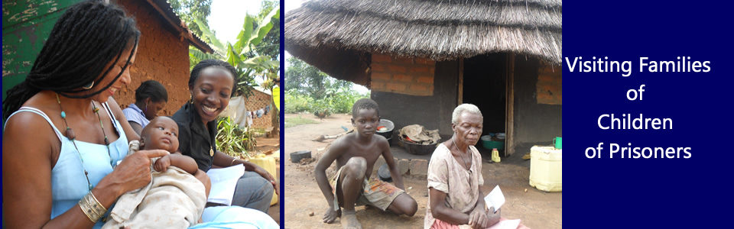
Concept
We were enthusiastic from the outset about the concept of an International Study Week since we believe this provides a unique and innovative way of exploring a specific social problem within its context, with those who are most affected by it. The most common forum for sharing knowledge within both the academic and NGO setting is through international conferences which usually focus on a large number of different topics; however a study week enables a deep exploration of a single topic. With a careful marketing strategy, we believe this would be a very popular and beneficial event for local, national, regional and international organizations working with vulnerable children. Our first observation therefore is that this is a worthwhile activity which should become an annual event- this will be especially important as the work of Wells of Hope becomes more widely known and other organizations want to learn from its achievements.
Hospitality and organization
It was apparent that a great deal of planning had gone into the organization of the Study Week. All of our needs were taken care of, from the pre-visit preparatory information; being met at the airport; reliable transportation for all visits; safe, clean, comfortable accommodation at the University of Makerere Guest House, meals provided and, regular email and telephone communication throughout the week to check on our wellbeing and to illicit our ongoing feedback about the programme. The hospitality was exceptionally warm and welcoming; this was reflected at every level of the organization and meant that friendships, trust and mutual respect were quickly established. The organization prides itself on developing the skills, especially interpersonal skills, of its staff members and we were privileged to spend a week with some of the most professional, courteous and compassionate people one could meet.

Programme
The schedule of activities was extensive and carefully thought through. The week commenced with sessions aimed at learning about the history and scope of the organization and meeting of Board and staff members. This was followed by the activities that have been described in this report. At the end of each day, a period of discussion and reflection was timetabled in – this enabled a thorough processing of all that had been learned throughout the day, identification of good practice and recommendations for policy and practice development. The programme was balanced and involved a mix of professional meetings, meeting children, caregivers and imprisoned parents. It is difficult to encapsulate the impact of some of these meetings on our personal and professional growth. We met fathers who were resilient and cherished their parenting role and clearly adored their children. Many of these men were joyous about life even though they had been sentenced to death and in many instances had been in prison for years. We met mothers who carried the accumulative weight of oppression and sadness and seemed to have lost hope. We met grandmothers who were astonishing in their capacity to love and to give even though they clearly were experiencing extreme poverty. We learned from the organization’s staff: social workers, teachers and matrons who were gifted in the art of caring for children and committed to their vocations. We were left in awe of the organization’s commitment to children’s rights; a passion it shares with ‘One Hope’. The most indelible impression was in meeting the children themselves and experiencing at first hand their ability to cope in the face of considerable personal trauma and the benefits they gained from being cared for by Wells of Hope. This was an emotionally and intellectually exhausting week and it was much appreciated that a rest/tourism and culture day had been built into the programme.

Knowledge-sharing
The Director of Wells of Hope, staff and Board members were very receptive and open to our observations and comments and we engaged in many mutually enriching discussions.
It is clear that at the international level, children whose parents are in prison have many experiences in common:
- Stigma and discrimination
- Loss and separation anxiety
- Financial deprivation
- Family break-up
- Impact on school attendance and performance
- Greater risk of involvement in criminal activity and anti-social behaviour
- Issues to do with parent’s imprisonment (parent’s crime, length of sentence, prison location and conditions)
- Contact with imprisoned parents
It was also clear from our observations and discussions that many of the issues affecting children are specific to a particular social and cultural context. For example, in Uganda, children are at greater risk of abandonment, HIV-AIDS, school drop-out, challenges in visiting imprisoned parents, extreme poverty and girls are at increased risk of sexual exploitation. However, the children also benefit from a culturally rich and diverse society which provides creative outlets and which in turn aids growth and development
The organization has some very progressive policies and practices however these are not as visible as they might be. For example, the organization has a forward thinking gender-sensitive approach which translates into providing income-generation support for mothers and prioritizes girls as beneficiaries for care because girls have fewer educational opportunities than boys and also to protect them from sexual exploitation. Other important policies include respect for the parental role of the imprisoned parent. This is translated into practice by enabling parents to refer their own children for support which in turn requires an acknowledgement that parental imprisonment has caused hardship for the children. In the men’s prison we learned about the committee the men have established to manage the referrals to the organization in a way that is fair, equitable and transparent and which ensures that men of all tribes, regions and religions have the opportunity to refer their children for support. Another progressive policy is the commitment to maintaining families and communities. This is translated into practice by ensuring that children maintain contact with their imprisoned parents, where possible that children are supported in their own homes and when children have to be boarded at the Academy; that they return home during school holidays. There are also positive policies in place in the school such as engaging people from the local community in jobs and construction, providing education to local children and ensuring that all teaching is carried out in English so that the children become fluent in this language as well as their own. One of the most impressive practices of the organization is the way they have managed to create non-stigmatized care and support of children who are living with HIV. Not only is this group of children (and parents) prioritized in the delivery of services, the organization (through its links with other organizations) provides HIV testing and access to ARVs. The children are fully integrated into the Academy and receive a good standard of nutritional care and support.

We also learned that Wells of Hope Ministries holds a position of respect among other NGOs, government departments, Prisons and the Prison Welfare Service and is singled out from among others as having a high level of financial transparency and producing measurable benefits. The organization has an enviable reputation for professionalism and achieving results – this was evident by talking to professionals, parents and children.
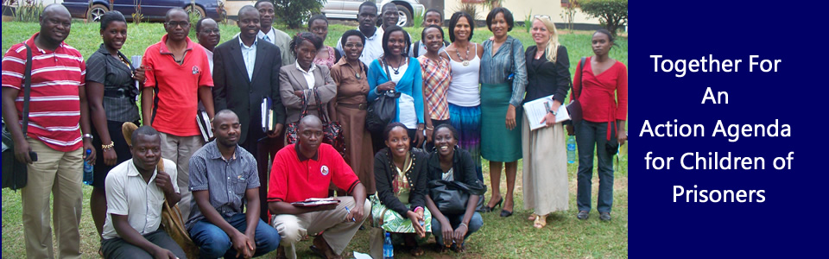
Achievements and Action Plan
We believe that the objectives of the Study Week were fully achieved and we greatly appreciate the effort of all those involved in organizing the programme; we benefitted from the experience at both a personal and professional level. There was also an additional outcome that had not been anticipated – the establishment of a formal relationship with the University of Makerere. During the week, an opportunity was created to meet with Dr. Eric Ochen of the Social Work Department and agreement reached to form a partnership for carrying out research. This will be supported by Prof. Jones at the University of Huddersfield, UK.
With regard to Wells of Hope, while the organization has some sponsors, it battles with endemic financial challenges on a daily basis. The rapid growth of its services and the very clear benefits to children and parents is all the more remarkable for this fact. That Wells of Hope Ministries has managed to purchase land and to build a school in this financial environment is testament to the commitment and faith of its founders, Mr. Francis Ssuubi and Ellen Ssuubi. The care it provides for 74 children is of a high standard and the children demonstrate resilience, and they are physically, educationally, spiritually and emotionally supported by a staff team that are compassionate and committed. Despite these achievements there is a clear need for urgent and sustained financial support for the following:
- Completion of school building and dormitories
- Installation of piped water, electricity and improved sanitation
- Salaries for staff
- Transportation
- Development of farming land (for sustainability purposes)
- Educational and leisure equipment
Recommendations – we suggest that the following action steps are taken and offer our ongoing support in implementing these steps
- To identify an external international development funding source to support the physical needs identified above
- To promote the work of the organization through conference presentations
- To establish the Study Week as an annual event in collaboration with the University of Makerere
- To undertake research into a) the numbers and impact of parental imprisonment on Ugandan children; b) the benefits of the care provided by Wells of Hope (evidence-based practice); c) the impact on and role of grandparents in supporting children of imprisoned parents
- To ensure that the policies of the organization are written and clearly evident so that others may benefit
Professor Adele Jones and Mona Kassarp

