THE 2ND INTERNATIONAL STUDY WEEK ON CHILDREN OF PRISONERS
23RD-28TH SEPTEMBER 2013
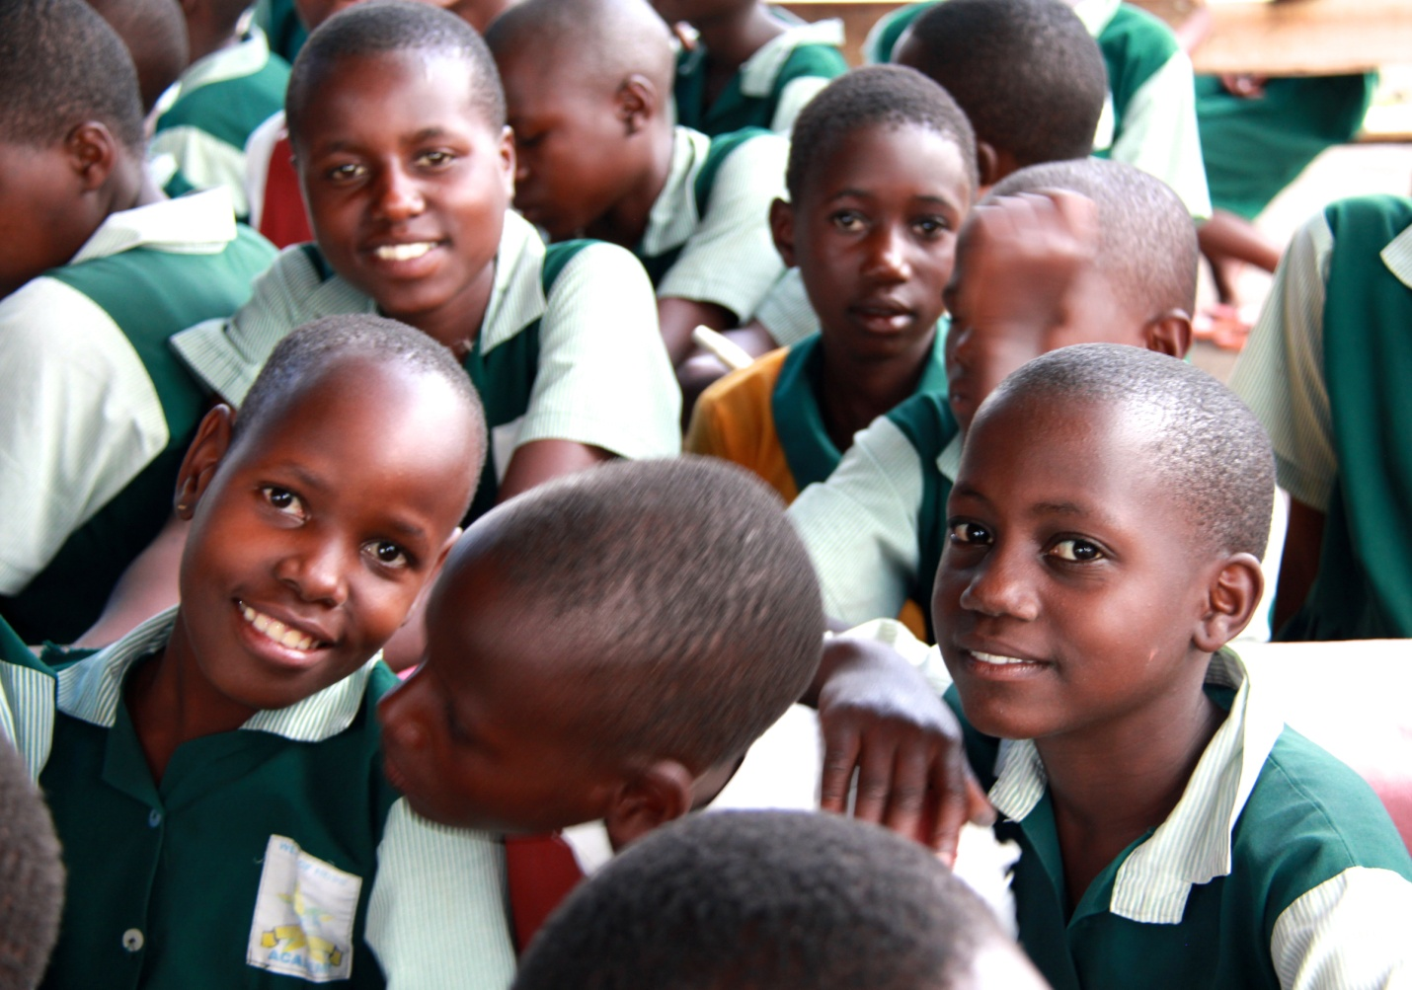

HOSTED BY: WELLS OF HOPE MINISTRIES

ACKNOWLEDGEMENTS
We would like to thank our esteemed visitors and participants, Benjamin Raikes, social science teacher at University of Huddersfield, Sharon Wray university of Huddersfield, Kathryn Sharratt, University of Huddersfield, Sarah Roberts, Families Outside and Rebecca Ginsburg professor, university of Illinois, Dr. Seruwagi Gloria, lecturer Makerere University for having taken part in our study week and contributing to its success.
Furthermore, we thank all the national delegates, many of whom travelled extensive distances, for participating in the closing seminar.
In addition we would like to thank all the organizers of the International Study week i.e. the members of Wells of Hope Ministries especially the Executive Director Mr. Ssuubi Francis, the Wells of Hope Team amongst others.
Finally, we thank all the different members/actors who are engaged in the fighting against the social evils affecting children.

BACKGROUND
The international Study Week is a specialized expedition through spectacular and unique interventions being carried out by Wells of Hope to mitigate the challenges brought about by parental imprisonment
Day activities were conducted were the participants met with the different key role players in the lives of children of prisoners to arrive at the role of grandparents in caring for children of prisoners. The study week was a trek into the loves of the forgotten victims of crime. During the week activities, children entertained the participants through Music dance and drama showcasing the traditions of Uganda while communicating the unspoken theme of the effect of death row on their lives.
Theme
“The role of grandparents in caring for children with parent in Prison on death row”
Objectives
- The aim was to consolidate our experience, to share new knowledge and skills, and to discuss the role of grandparents in caring for children with parents on death row
- To promote friendship, solidarity, and one spirit among people serving vulnerable children specifically those whose parents are on death row, from all over the World.
- To inspire and motivate other people to join the collective endeavors aimed at mitigating the plight of children of prisoners.
- To bring together individuals and organizations involved in prisoners children’s work so that they can network and learn from each other.
- To showcase the work being done by Wells of Hope to mitigate the plight of children of prisoners and also to help the participants to be inspired and learn from it.
- To educate participants about the effects of death row on children and grand parents
- To raise awareness, lobby and advocate for children affected by death row
- To raise awareness of the plight of children of prisoners at a global level and to discuss effective solutions to address the problem of children of prisoners worldwide and also acknowledge the role played by Grandparents in the lives of children with parents on death row.
- To mobilize support and form more partnerships to support the Wells of Hope and other organizations engaged in this work.
- To build lasting friendships and networks.

SATURDAY, 21ST SEPTMEBER, 2013
Meeting with Sarah Roberts, Families Outside, Scotland
She met with a team from Wells of Hope which Included Francis Ssuubi, Executive Director, Ellen Eva Ssuubi, Board Member, Jacqueline Sekyana, Administrator, Marjorie Lunkuse Outreach Coordinator and Berna Bakulumpagi Head teacher Wells of Hope Academy.
The system of Pastoral care was described, where a teacher is given to look after a certain number of children, all siblings must be in the same group, the teacher gets to know the children, their family and also more about the personal lives of the children. The teachers meet with each class once a week; they are in charge of monitoring attendance of the children and also find ways of improving academic performance of the children. This is a system that has been used in Scotland and it proves very effective
Teachers need to be committed and also have the heart and concern for all the children entrusted in their care.
She had started out Started out with only one family where she went to prison to visit the mother to the children. She says;
“I went to visit a prisoner but I met a mother instead”
Through these visits and getting to know the history of the children, the teachers get increased motivation to teach these children and even the children get improved self esteem as they have a teacher they can rely on and feel safe with
In Scotland, there are over 27,000 children of prisoners way smaller than what is presumed in Uganda of over 100,000 children of prisoners
Families outside started out by organizing trips for teachers to prison so that they get a day to walk in the shoes of the child to feel what the children feel every time they go to visit their parents in prison
We need a community of compassion where children are not stigmatized, do not have to be in hiding and especially do not have to feel guilty because their parents are in prison.
Mrs. Bakulumpagi, Head teacher Wells of Hope Academy; At WOHA, it is one big family, the children all understand the different struggles their friends came across and they do not judge one another, they are understanding and consider themselves as one big and happy family. At the school there is no bullying of any sort and the children have greatly been morally uplifted through the spiritual dedication of the staff of wells of Hope, so it is right to say that in many times so many of the children with parents on death row have greatly relayed on faith, and spiritual understanding to give them peace
Marjorie Lunkuse, Outreach Coordinator WOH, also at WOHA, there was a project which had been started called the love project, where a group of 10 children were put under one group and given a teacher to monitor. Though the only difference is that we did not group siblings in one group which we should look into so that the teachers get acquainted with each child and family as a whole
Most of the Teachers need to be sensitized about the situations of COP because training teachers is very important as the children spend almost 90% of their time with these teachers, who then need to be well aware of the situation of the child back home.
At WOHA, a new teacher who didn’t know where these children come from once visited with them in prison and met with the mother of the child, she got a deeper understanding of why this child acts the way she did and so she endeavored to counsel the child and not just dismiss the child as a bad seed and now the child shows promising results both socially and academically.
We should understand that many teachers want to support these children in any way they can, and all they have to do is understand the back ground of this child, know where he/she comes from and then teach accordingly.
Teachers also need to be aware and they too should meet as groups so that they can get deeper understanding of the issues affecting the COP in order to improve on their education
We should endeavor to make sure Prison officers understand the family agenda, for example, how they greet the children when they come to prison to visit their parents, they should not treat them like the other adults, checking without considering the fact that these children are scared and nervous, all this should be put to play while receiving children on visitation days.
Reception of children at the prison should;
- Be friendly
- Warm
- Hospitable
- Not scary

DAY ONE -23RD SEPTEMBER 2013
Summary
On the first day of the study week all the participants met at Wells of Hope Ministries’ office. Key issues concerning the welfare of the children of prisoners and the betterment of the organization as a whole were discussed. The participants moved to the Prison Headquarters where they met with the superintendant of prisons Natunkunda Aliyo, from there they moved to the National council for Children where they met with the secretary general, Kiiza Martin, the final destination was with one of the partner NGOs of Wells of Hope at the Uganda Child Rights NGO network where they met with the executive Director Stella Ayo
WELLS OF HOPE OFFICES ON 23RD/09/13
The participants were welcomed by Mr. Ssuubi Francis, Executive Director WOH who ushered them in office; he gave them a brief background of the study week. They were told stories about the children such as Mary Namugula, Muhindo Brian, Namata Rose .They went through the children’s files and other files such as the prisoner’s application forms, reports. The participants reacted by asking questions such as how do you recruit children, what if a child was offended by his father or mother ,how do you handle ,which prisons do you work .what are some of the other activates that you engage in.
- We take forms which are filled in by the inmates directing us to their homes, we get children who are between 5-14 years, amongst the children one has to be a girl and we get only two children from each family
- We have counselors, who are always with the children, at least once a week, they get to talk to these children and the parents as well, but WHO does not force a child to see the parent, it is the decision of the child and we have seen over time that so many children have reconciled with their parents.
- We work with the main prison in Uganda Luzira men and women prison, because it is the only prison that has the type of people we work with i.e. they have to be sentenced to death, suffering from HIV/AIDS and or have long sentences of over 5 years
- Other activities we engage in include, we take food supplements to inmates, we carry out bible studies, and we facilitate psychosocial trainings amongst inmates and spouses of inmates.

THE UGANDA PRISON SERVICE HEAD QUARTERS ON 23RD/09/13
The participants were welcomed by Natukunda Aliyo, the superintendant of prisons
Self Introductions were made by all participants in the study week, the members from wells of Hope and the members from the prisons department
Executive Director, WOH (ED) introduced the relevance of the study week which is to highlight the plight of the children of the prisoners and forge a way forward. We come to learn from one another and get involved in the work which we are doing in helping COP
The study week brings us together, together to learn and get practical solutions and to also recognize the efforts done by the organizations in this regard
Role of Uganda prison service
Vision
To be a centre of excellence in providing human rights based correctional services in Africa.
Mission
To provide safe, secure, and humane custody of offenders while placing human rights at the centre of their correctional programs
The prison is governed by the prison act of 2006
The act provides for infants to stay with their mothers until 18 months. The prison guard is supposed to make sure that the relatives are able and willing to look after the children, if they are not the welfare officer works hand in hand with other organizations and they hand over these children to the willing NGOs.
The relationship with the Uganda Prison Service (UPS) and WOH is based on these rules for the betterment of the inmate after release
Early childhood development is very important and it is the responsibility of the welfare officer to make sure that these children are put in homes which will nurture them, protect them and also ensure that they get the chance to grow up healthily
The welfare officer is in charge of Inspecting facilities where children of prisoners are taken either to the homes of the next of kin or even the NGOs which would take on these children.
In some countries it is recognized that visitations are used as an incentive for good behavior but this is not right because children should stop being punished for their parent’s misbehavior.
Prison is not a place a for a child to grow up and it should always be the last option for the mothers because the conditions are harsh and the prisons were set up for adults, they do not have facilities to cater for these babies
In the female prison at Luzira, they are putting up day care centers outside the prison walls for the young children, an initiative done by a priest to give these children who are not wanted by their relatives a place to stay and also keep in touch with their mothers while in prison. The prison department has not done such an initiative yet because of the lack of funds for the project.
Through the UPS;
WOH gets permission to enter the prison gates whenever such permission is requested for with little and at most times limited difficulty
An MOU has been written between the UPS and WOH to bridge and bond the working relationship they have
The form that the inmates fill in after they have been sentenced, the number of children one has should be incorporated in the questioned asked so that Uganda can also come to know the exact number of prisoners’ children on the country.
What has WOH done for UPS?
WHO has helped UPS meet their mandate through giving food supplements for the inmates suffering from HIV/AIDs?
Spiritual needs of the prisoners through the constant and dedicated bible studies
Improved security through looking after these children causing stability amongst the inmates who no longer wish to escape but can serve their sentence at ease knowing that their children are well looked after.
Allow children to visit and use the prison officers’ offices for the children to have direct contact with their parents unlike other children who come individually and do not have direct contact with their parents, those that have to see the parents through a wire mesh.
Challenges
Many needs with the inmates which WHO cannot handle all of them due to insufficient funds
Many inmates would like WHO to take on their children yet we can afford to care for a few
Death row section, people come from very far and so in many cases tracing for their families is very hard and most of them have lost contact with their family members.
Where are we going
Prisons finds it hard to place these children in the homes of the relatives, especially to trace for these families, WHO can partner with the UPS since they have experience in tracing and take on the responsibility of tracing for the family of the inmate, counsel them before they reintegrate the child not the home.
We should consider taking on younger children especially the boys who are molested in prison and the only person who can help them also cannot look after all of these children
Female prisoners are allowed to come in with their children but the law does not allow the men to come in with their children and yet in many cases you can come across when the man was the only guardian the children had and so after imprisonment they are left to fend for themselves.
The forms filled in by inmates should be revised and ask how many children an inmate has, this will also help in the government planning so that they can consider the number of children who are left without a care giver.
WOH has plans of sensitizing schools about the plight of children of prisoners, so that they may become more sympathetic to these children and teachers will understand why they may behave the way they do.
Challenges
There is very poor communication between the relatives and WOH, in many cases the relatives have abandoned these children at the school and do not want anything to do with them guardians give excuses about money so that they do not have to stay with the children during the holidays and always ask the children to stay at the school which increases on the expenses of WOH
Parents don’t want to take on the responsibility of their children after release and at most times they disappear leaving the family to continue to fend for themselves. In some cases the fathers ca not go back to the home village due to the crime they committed and so they decide to disappear because they do not want to take on the responsibility of looking after the children when they cannot afford to.
Recommendations
Sarah Roberts, Families Outside
Regular meetings with prisons officers should be scheduled so that they are always aware of the situation going on with the children and also for WOH to be aware of the release dates for the inmates.
We should consider having specific projects with the UPS so that we can partner in many ways e.g. in family tracing, counseling and reintegration of infants back to society
Organize for theme days in prison and organize parties where the parents get a chance to be counseled

Ben Raikes, Social Worker, University of Huddersfield
So many times after a mother has been imprisoned, they lose confidence and self esteem and cannot easily talk with their children when they come to visit.
There is a prison in the UK, where children can come and stay over the weekend in a house in the prison grounds which gives them a chance to be mothers once again, they can get time to talk about the problems they are facing and also get advice from their mothers without worry of the time as it is always very hard to talk about problems in a 2 hour visit, during that short time, they would rather just talk about only happy things and go back home with the problems which is very negative on the child
Sharon Wray, University of Huddersfield
Most COP are left under the care of the grandparents which is very hard because they are old, sickly and no longer have a source of income, how this affects the child and the inmate in prison is very hard.
The different groups may have a different take on how to raise their children due to the different generations.
The main intention was to learn the relationship between parent and grand children and children in prison
Rebecca Ginsburg, University of Illinois
It is not usually the practice of the school to ask children if they have a relative in prison. Most schools do not consider COP as a special case and that is why they are not recognized in schools and yet they are there.
We should work to ensure that we hold trainings to look out for theses children and give them the extra support they need. It might not be financial, but emotional support and also at times just someone to listen to
During children’s visit, the visitation area makes a huge impact on the children, it is good to have a child friendly environment so that the children can feel comfortable to open up and talk to their parents about all issues happening in their lives. Prisons invest in making family visit areas friendlier so that the children can feel comfortable and not frigid and scared.
The availability of a platform for these children to talk and share with their parents in prison reduces the rate of recidivism.
Education system in prison
Education is for the Convicts of 10 years and above. There are seven (7) learning centers to include the Primary Leaving Examinations (PLE). Secondary education is in the Luzira in upper prison only. The teaching is done by the inmates themselves and also some prison staff who has an education background as teachers takes part.
It is only in the main prison in the country and not in other prisons
There is a very huge need for the education system in all other prisons, so that the other inmates get a chance to also learn.
The impact is very large as at the present many inmates who were illiterate can now read and write with the utmost ease and can easily communicate with their children who are studying; this is most exciting for them
Currently there is only one inmate who has managed to go up to the University level and she is studying law by correspondence
Through the prison education program, most of the inmates will be able to get good jobs after release with the right attitude and dedication to the system.
The education program has also led to some inmates Inspiring fellow prisoners when they are released and can get better jobs than the ones they would have had they not gotten the chance to go back to school while in prison.
This is also a way of ensuring that the inmate will have a better chance to take care of their families, more opportunities available to them
Currently there is a big need for qualified teachers and resource persons to teach in the prison schools, as since it is a government imitative it is poorly funded and does not attract the right personnel.
Grandmothers play a big role in the lives of COP; most inmates have left their children in the responsibility of the grandparents
ED, the Welfare officers in women prison and upper prison help a lot especially during the times when the children are visiting, in most cases they have offered their offices for the children to use during the visitation
Recommendations
At the end of every child’s visit to prison, reports should always be written to include challenges and recommendations met during the visit to the commissioner of prisons. This will give room for them to advocate for new and better visiting rooms and maybe a joint proposal between UPS and WOH can be made to improve on the facilities of the visitation areas for the children.
At the National Council for Children
The meeting was chaired by the secretary General of the National council for children Martin Kizza, Self introductions were made amongst the participants
He introduced what the NCC is and where it has come from. It was established by the law NCC act 60 to carter for children, to ensure that their rights are monitored and implemented and they rotate around the 4 pillars of summit
- Protection
- Health and survival
- Development
- Participation
NCC Works with different line ministries to make sure that they work with NGOs, FBOs, CBOs to deliver services to the children

How they work
- Different people through M&E
- Project evaluations
- Communication and advocacy
- Capacity building
- The upbringing of the child determines the next generation
- Monitor organizations work
- Advocacy forums, child labor
- ECDF conception
- Children and HIV/AIDS
- Monitoring & Evaluation
He went on and thanked WOH for participating in the Day for the African Child which took place in June, 2013
He went on and stated that unfortunately the National Strategic Plan Initiative doesn’t state children of prisoners as a vulnerable group and simply groups them together with other vulnerable children.
What can NCC do to help WOH
UN resolution, Uganda being a signatory to the UNCRC, it is important that we may start following the resolution as far as children are concerned and we can endeavor to do this through working with the NCC.
Being an era of information, it is imperative that we should always be willing to share all the information that may come up in the line as we work to help improve the lives of children in Uganda.
A follow up meeting with the NCC should be organized to ensure that all that has been discussed is followed up.
Ben Raikes; He advised that a strategy of training should be made so that we can all have the same work methods since we are looking at the same goal
Sarah Roberts; she said that in the UK the children of prisoners had been recognized as a vulnerable group of children and so Uganda should borrow a leaf.
Sharon Wray; There is no support for grandmothers who support children with parents in prison
The State needs to acknowledge this fact and make sure that they provide these grandmothers with the support they need
The government should be made aware of the impact of the death penalty on the children; they should listen to the stories of the children and the grandmothers
We should network for regular meetings with the agenda for children of prisoners so that we can forge a way forward for the COP in Uganda
UGANDA CHILD RIGHTS NGO NETWORK
UCRNN was set up to monitor the situation of the children in the country and progress of intervention.
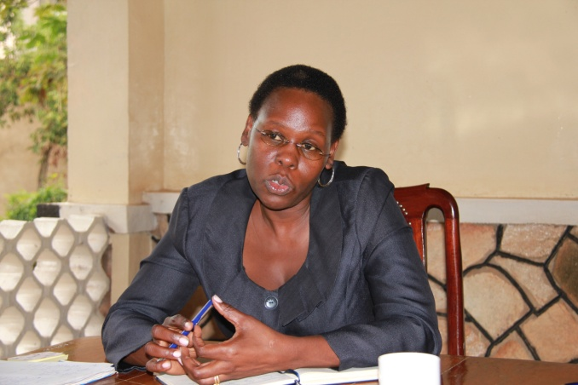
UCRNN is all about collective advocacy and strengthening NGOS which work with children
They work hand in hand with other member organizations to ensure that the rights of children are upheld in Uganda
Work with different organizations that handle different groups of OVCs e.g orphans, child soldiers, defilement, disabilities
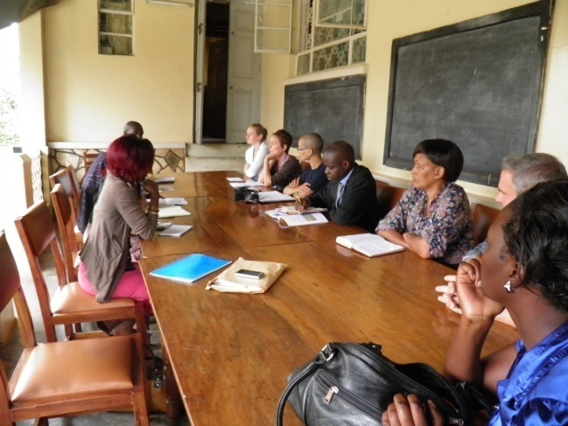
There is a great need to concentrate on the issue of justice for children where even the COP fall
In Uganda currently, it is very important that all children are registered at birth but unfortunately they are not because;
- Many are conceived through defilement
- Forced and early marriages
- Many cannot access health facilities
It is known that most COP don’t know their birthdates.
Areas of interaction for UCRNN
Members sign up on any of the thematic areas to include, violence, Justice, war e.t.c
How do they work
- Offering a platform to influence policies
- Works with the parliament
- Child rights forum
- Mobilize resources
- Help in information sharing and practices
- Child protection
- Child health plan
Reporting gap where some information is not communicated to the right authorities, UCRNN is working on a toll free line where they would like to include the drop for children of prisoners.
Uganda has a child friendly policies and law but there is very limited implementation of these laws
UCRNN takes part in monitoring handing in reports to the UN and before the next report is handed in WHO should add something about the state of children of prisoners in Uganda.
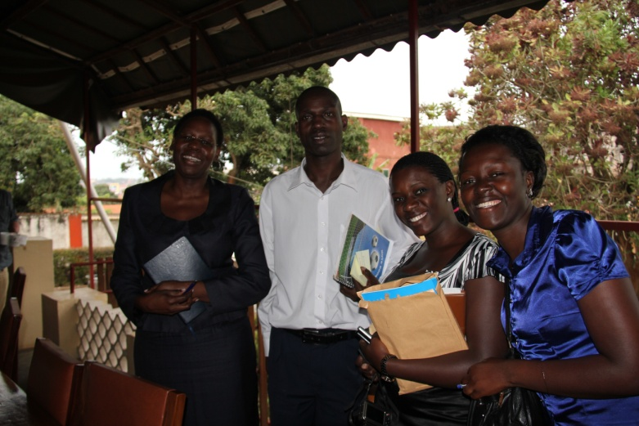
How Wells of Hope works
We use the triangle approach, we get in touch with the parent in prison, who sends us out to his family who then give us the children whom we take to the residential school WOHA where the child is looked and cared for.
Challenges
We are greatly misunderstood; people think that we help the children who are staying with their mothers in prison which is not the case because there are other children of prisoners who are not old enough to remain with their mothers in prison.
The government needs to come in and help these children of prisoners as it is the social responsibility of the government to ensure that the children who are left behind after the parent/carer has been imprisoned are well looked after.
Need to work together to ensure that the UN resolution is implemented
Build a synergy with FHRI so that we can fire up what they have already started to deal with the death penalty so that maybe the voice of the children will make the a bigger impact. We need to use the child perspective in the abolition cause.
We are an information based era, we need to share information with others about people who come in contact with children of prisoners, through all the different means possible. This is abit tricky because access to internet is very limited in Uganda and yet the members come from different parts of the country
Ben Raikes; a website were different people who have come in contact with children of prisoners share their experiences and encourage one another, that would be something good for us here in Uganda.
COPIN project, this mainly focused on the quality of relationship between parent and child. i.e. how the child manages to cope with the situation of having a relative in prison.
The research was looking into the mental health of children of prisoners, what it is like for grandmothers to look after children of prisoners and how do they get the money, how do inmates feel about their parents looking after their children with the difference in culture generation and upbringing.
What factors lead to crime
- Poverty
- Illiteracy
- High levels of unemployment
Way forward
- We can use people’s forums in order to spread the word about children of prisoners
- Sending programs to interest people in the work being done by WOH
- Add on drops to the child help line for COP
- Need to share information through emails
- Have follow up meeting
- WOH to participate while UCRNN writes a report to the UN
Review Meeting
The participants found out more about the work of WOH
The profile which was included in the information pack has greatly helped to summarize the work of WOH, it is very informative.
The office is very organized though in a small place
Questions from participants
What is our budget to run school and the office?
While we organize for the next study week, we should consider getting the view of an ex prisoner whose children are still under our care.
About Prisons;
How much policy actually goes in practice? They have the right policies to follow but are they implemented especially to go with the children and their mothers while in prison.
Some policies governing the prisons are similar to the UK
There are some positive innovations at the women prison like the day care centre which must greatly help the mothers while they are in prison.
Need for regular meetings for specific projects with the prison authorizes so that we may start to work together and this will ease the work we do with them.
Since we work with the prisons department, it is imperative that we know who is who in the prison hierarchy and so we therefore need a diagram of the structure of the prisons service/departments
National Council for Children
Unfortunately we failed to keep time and we are very sorry for that.
With the NCC there is a big opportunity for WOH as an organization and so it is important that we network with them so that they can help while we work with COP.
The participants were glad that we were able to use their presence to build stronger links with different organizations
Uganda Child Rights NGO Network
Stella makes things happen/ action oriented and if we proceed to work with her she will be able to open many more doors for WOH

Day Two 24th September, 2013
Luzira upper prison condemn section
It was amazing how easily the team made it through the check points at the prison because of the bureaucracy it always takes over one hour trying to be cleared before you are allowed to enter the prison gates, but in a very short time, we were allowed to get into the prison.
We were warmly welcomed by the inmates in luzira upper prison condemn section, they started off with the Praise and worship where everyone took part in the singing and dancing
The participants were then welcomed by the chief ward leader Onjangole John who asked everyone to feel free and comfortable
The inmates performed many traditional songs and dances from different regions, there was also the choir which sang many beautiful songs, and the participants were greatly warmed by the happy and hospitable inmates.
Testimonies from inmates were given;
Shafic walusimbi; He thanked WOH so much for the good work they continue to do with the inmates of the condemned section in Luzira. He said though being a Muslim WOH has helped him as they took on his children and they are now very happy at WOHA.
(other testimonies are attached see Appendix I)
Kunya Samuel; another inmate and also a beneficiary of WOH gave the memorandum from the inmates. The memorandum included some of the challenges the inmates face while having children and not being able to take care of these children, a challenge of the children having to grow up in the religion of the parents amongst others. (See Appendix II)
A beautiful and short sermon was given by Sarah Roberts; she said that the most important things in life are Faith, Hope and Love, we should never lose faith in God, faith that there is a mightier power which is looking after us, we should always hope for the best out of life, Hope for a better situation and never stop loving, God, our neighbors, our friends, our children. Never stop loving.
Meeting with parents/inmates/beneficiaries
Testimonies were shared by the inmates to include the fact that through WHO children can now speak English
Question 1: what do you think of the caretakers who look after the children
Some caretakers are wives who have negative attitude towards the children; because they have remarried they mistreat these children blaming them for the crimes their fathers committed.
Some care takers are the grandmothers and they have a lot of worry and a big burden they think of the imprisoned son and that causes a lot of misery to them, and also look after the grand children and yet they are very frail and old.
Even if before they had been arrested the grandmothers used to look after the children but by then the sons used to come in and give financial support which they can no longer give because they are in prison.
Inmate 1; says that his mother looks after him and the children, while in prison she is the only one who comes to visit him and yet she also has to look after his children
Mother has HIV/AIDs and has no form of financial support; he would have been the one helping her but cant because he is in prison and so she is left without any support.
Inmate 2; he was imprisoned and he left five (5) children behind to be looked after by his grandmother, the grandmother is very poor and elderly and doesn’t come to visit him anymore or even the friends, while in prison he is left alone only the connection of his children through WOH is the only connection he has to his family
Most of the inmates are from poor families and poverty stricken areas.
Inmate 3; My mother is 80 years, she cares for my children she is elderly and sick but she too cannot let her grandchildren starve to death so she tries and the little she gets she shares with her grand children.

Grandparents lose hope once a child has been condemned to death
There is need to sensitize Ugandans on the impact of the death penalty
Question 2; what is the Importance of education to the inmates and the children
- Education is the key to the future
- Most inmates committed crime because of ignorance
- Don’t want the child to follow in the footsteps of the father in prison and education will help the child know what is right
- Improves level of understanding and standard of living
- Education is an investment for the future
- Education is a source of discipline for the person acquiring it
- Education helps you to differentiate between cultures so learn how to deal with people and not resort to violence
- Education helps unite people without discrimination
- Education is the foundation of development and love
- Education leads to different levels of thinking
- Want to expose children to reality-role of individuals towards development
- Protected from illiteracy
- Education leads to fighting crime
- Ignorance leads to crime
Question 3; Statistics in Luzira upper prison -condemn section
How many inmates were educated before they came to prison
- Primary level 16.6%
- Senior six level 12.5%
How many inmates have completed studies from prison
- Senior six level 8.3%
How many inmates are currently studying while in prison
- Both primary and secondary 41.6%
How long have you been in prison since you were sentenced to death?
- 10 years and above 16.6%
- 5 years and below 41.6%
Question 4; what needs to be done
- Grandmothers need YGAs to support the children left in their care while the parent has been imprisoned.
- Helping grown up children above s.4 with YGAs especially vocational studies
Question from the Inmates
Where will WOH be without Francis;
WOH has a structure which has been build over time which is meant to mean that WOH will be around even after we have all left; even after Francis has left WOH will still stand
Luzira Women prison
In the afternoon the participants went to the women prison where they met with a group of women inmates. Self introductions were made, the participants sat in a sharing circle with the inmates to make them feel comfortable
Katushabe Charity
She was arrested in 2000 January, 31st and by then left a daughter of 19 months old, upon her arrest her property was destroyed by the community members and her mother was almost killed and driven out of the village
WOH got her when she was in p.4 she had to repeat p.4 rented a house for the parents and paid school fees and transport, support the parents spiritually and physically. She is now in s.1 and speaks good English. Grandmother looks after her in the holidays, family has abandoned her and rejected her

Challenges the grandmother faces
- The father abandoned her after she committed the crime and so the child was left alone.
- Things destroyed by the community members because of the crime which was committed
- Grandmother is also seen as a criminal in the society
- No one cares for her anymore because she gave birth to a murderer
What is the role of poverty in causing crime
- It’s not poverty or education, its anger and failure to forgive which brings people to prison
- Conflicts of family, children and land
Statistics
People who went to school before imprisonment 1/7
People who went to school while in prison 2/7
Mama Evaline(inmate)
Her children are not in school, she was imprisoned when the children had one month to go to school, and so there was no one left to help these children continue to school after their holidays so they stayed home. Her husband died after she had been imprisoned and he had no brothers or sisters to look after the children. She had stayed on remand for 18 months before she was acquitted. The children were staying with her mother but they were being mistreated by her other relatives. Right now the children are learning English.
Imprisonment doesn’t discriminate, rich, poor, educated, not educated, any one can commite a crime and end up in prison
Bony(inmate)
Problems faced while in prison
- Rejected by the community and family members
- No justice in court/quick justice which is never fair
- Unfair sentencing
Imprisonment does not affect mothers differently, they face the same problems as those who are not mothers, there is no cultural differences.
We should include the Child impact assessment in court while a sentence is being read, so that the children are not left to suffer.
Needs of the inmates
- Visitors-spiritually and material friends
- Get materials and market for their crafts
Challenges
Looking for double sponsorship where they want WHO together with another organization to help the same child. They were advised to be patient and stick to one organization which will help them.
Statistics in women prison
Total number of Female inmates 360
Children 31deathrow 29
Condemn 315
Meeting with the Officer in Charge women prison
Luzira women prison receives inmates from different prisons after they have been sentenced to a long term, some inmates come with children others when they are pregnant and have to give birth from prison. Those who come with their children lack of relatives who can look after these children.
In prison there is freedom of worship and rehabilitation activities to make these women better citizens when they come out. The rate of recidivism is low in women than in men, because women are more emotional and tend to learn their lessons faster than men. There are some rehabilitation activities like;
- Tailoring
- Crafts
- Catering
- One university student doing law by correspondence
Children get less time with parents if they don’t come with WOH, those children get maybe 15-30 minutes maximum but those that come with WOH, get even more than two hours while they are with their parents, there are three visiting days in a week, i.e. Tuesday, Wednesday and Thursdays.
Review Meeting
Prison was over whelming, meeting the inmates and sharing with them.
The music and entertainment in the men prison was amazing and it helped to reduce stress and tension between the visitors and the inmates.
It is amazing how they trust the men in prison; they can leave them to talk with people without any guards to watch over them.
The day had been very emotional and amazing, especially the sharing with the women.
Unlike for the women prison there was no warm up and so in the beginning there was a lot of stress and tension, we should consider also women being more involved and maybe start with songs to cheer them up and release the tension. It also helps to transcend the language barrier
Women who come from far should be allowed over night stays with their visitors so that they get time to extensively talk with the visitors about the current issues
Those inmates that are sentenced to death with HIV/AIDs have a double death sentence
There is a great sense of community in the prison and they appear like they encourage each other through such trying times which are very good.
Rebecca; Glad to have gone
Discussion on poverty and low education levels and how they have caused crime in Uganda, all the inmates where really involved in the discussion and the men really appreciate all the work that WOH has done for them, the work is so involving that the inmates too participate in the program design and offer good critical suggestion. The men had the confidence that WOH will continue to provide these services for time immemorial which is very good.
Women abit hesitant to voice their stories maybe because they were not so comfortable with the strangers but later started feeling comfortable and could easily talk
There is a great relationship with the prison staff and WOH team which shows how much WOH has been putting into this work and this happens and such relationships are built over time
They were glad when they voiced the opinion and were given good answers when the inmates wanted to know what happens when Francis is not around, the system in place to ensure that all goes well without Francis is good and greatly recommended
Importance of culture, history changes in different places, different structures and culture shouldn’t oppress us
The prison welfare officers should partner with WOH as they have the experience in family tracing so that when reintegrating these children back in their homes, WOH can do it.

Day Three 25th September, 2013
Wells of Hope academy
The scouts welcomed the visitors and ushered them into the Head teacher’s office where they met with the head teacher.
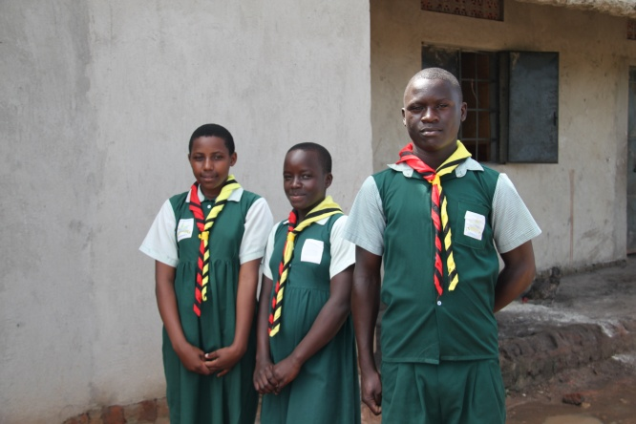
She welcomed the guests and introduced WOHA, a school for children of prisoners with currently 91 children of prisoners and 37 children from the community.
The guests started the tour of the school with the boys dormitory, where they met with the mother, they were very impressed with the cleanliness of the dormitory and thanked the matron for keeping the children clean and neat
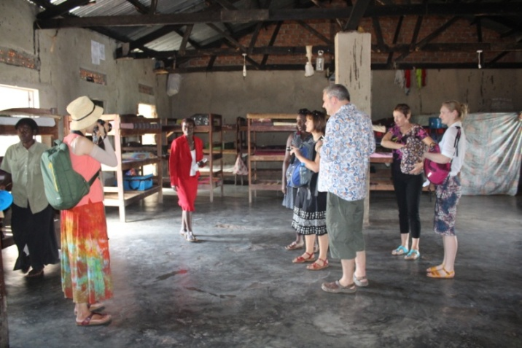
Wondered whether they needed mosquito nets as some children had and others did not have the nets, they said that they can organize and send some nets for the children.
Next they moved onto the girls’ dormitory, met with the matron for the girls, they said that the bathrooms were very good and full of light for the children.
Toured the animal husbandry section, with the chicken house, the kraal and the pig sty, they were very impressed with the efforts wells of Hope is taking to make the academy self sustaining
Went through the classrooms with the exhibitions by the children starting off with the self realization club which included the Girl child Network where children exhibited how to purify water
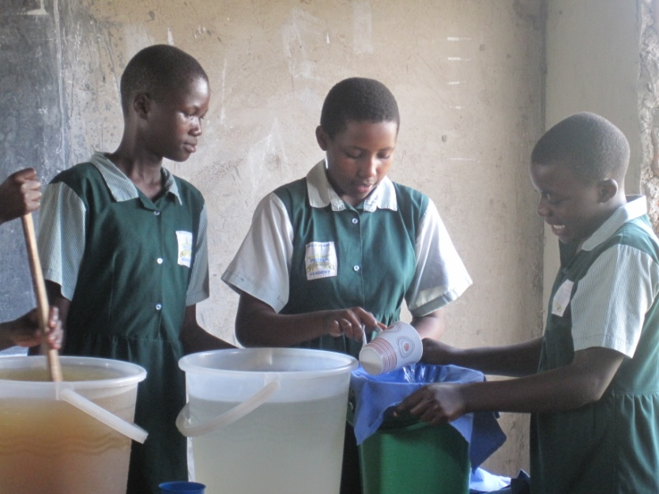
The next was the arts and crafts club where the children exhibited the different arts and crafts projects they have been engaged in to include, clay models, beaded art, tie and die art, dolls out of banana fibres e.t.c
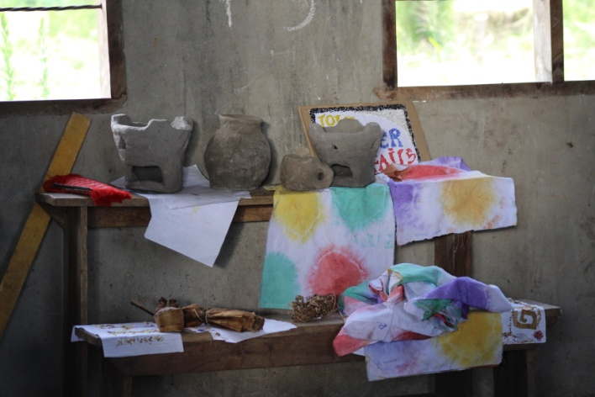
Next was the scouts club where they exhibited what happens in the scouts club, they showed off some ropes made from banana fibres and also showed how to use the black stone after you have been bitten by a snake, as first aid
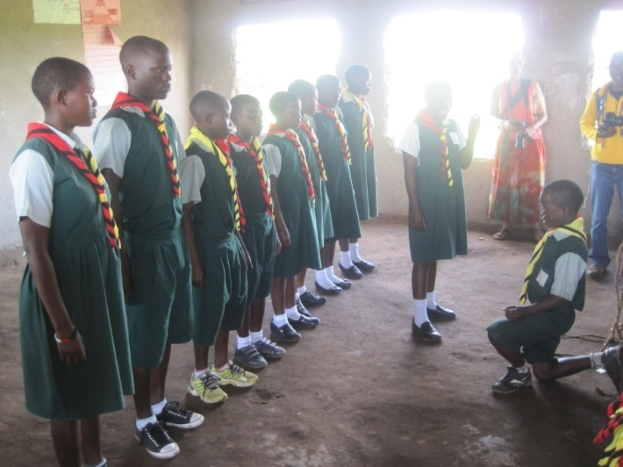
Next was the first aid club where children showed the advantages of having firsthand knowledge on first aid and also showed the first aid steps given to a person who is choking with a particle in their throat
There was also the faith club, where children recited memory verses and also showed the different religions commonly in Uganda, to include Islam.
Lastly was the Music Dance and drama club, they showed a bit of the dances and also ensured the participants to wait for more coming ahead.
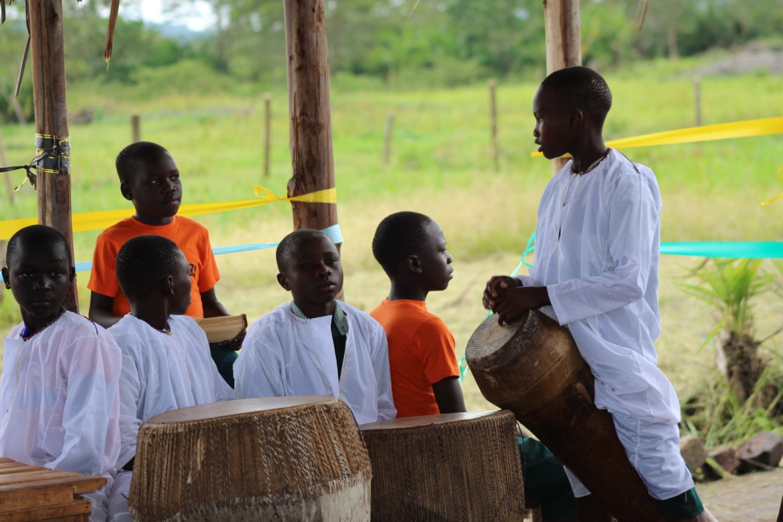
After the visitors went in front of the HM’s office and being led by the scouts, they hoisted the flags, sang the national anthem, the school anthem and also had the opening prayers.
Shelter
The participants were welcomed by Francis Ssuubi, who introduced them to the children as people who had come to learn from everyone.
The children entertained the guests with songs and dances from the Music Dance and Drama club and also from the school choir. It included the western ballet dances, traditional mimes and dances from different parts of the country.
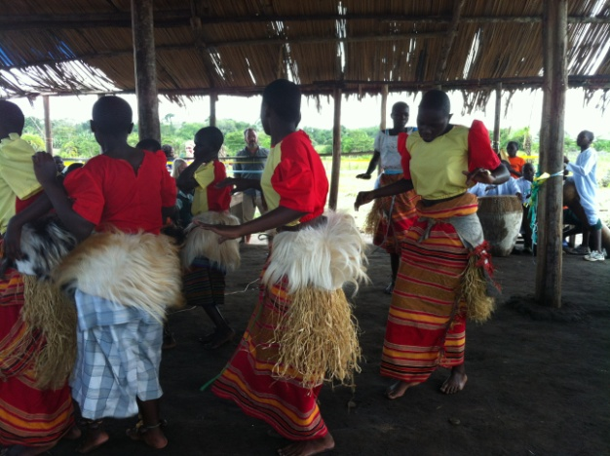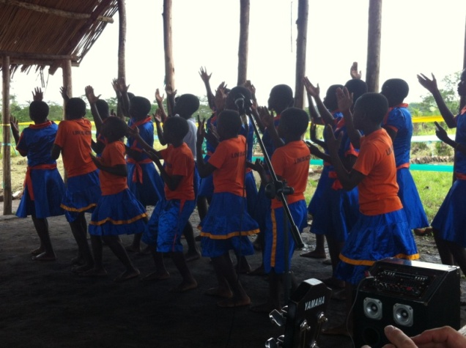
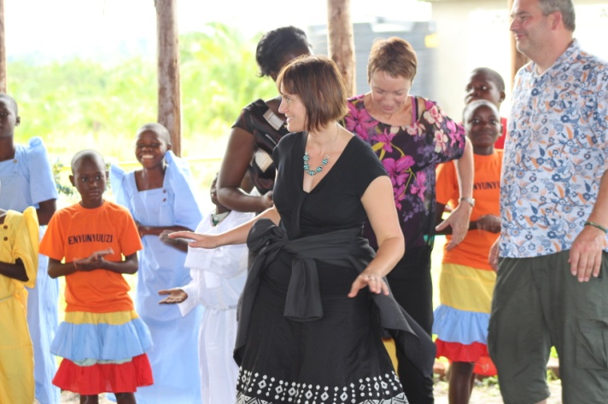
Ben Raikes addressed the children, he told them how happy all of them were having gotten the chance to come and visit Uganda, and that they had been to prison and had met their parents who all sent them greetings, he explained that they had come to learn more about the situation of children of prisoners in Uganda and that they were very excited to get to know the children much better.
He called upon Sarah Roberts, who had brought a present for the school, a book about the history of Scotland, a book which the head teacher received and promised to teach the children all about Scotland, she also handed over some pens which were given out to the head teacher.
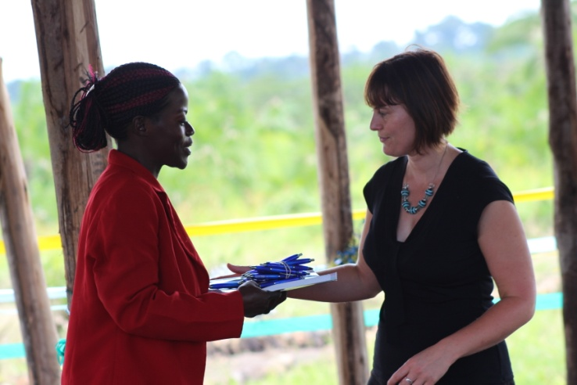
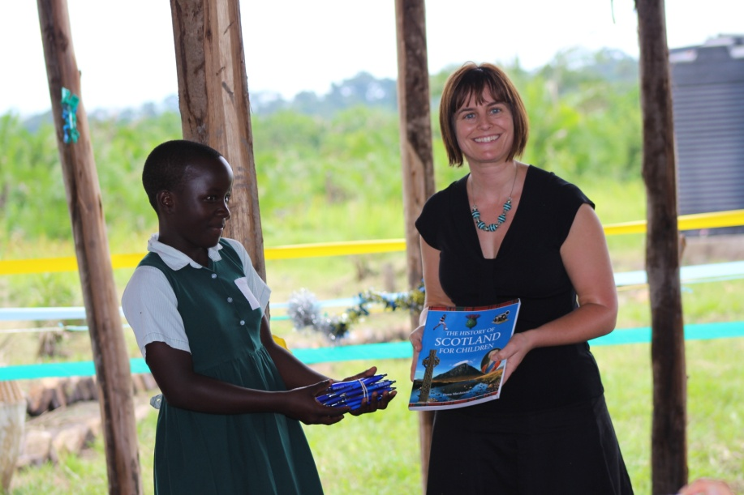
There was a beautiful traditional mime which was presented by the children about a family where the husband became a thief and stole money with his friend, the money they stole they instead used it to get drunk, after he was arrested and the children remained alone with their mother and grandmother, their mother soon left them hungry for another man and the children remained with their grandmother, they were suffering until wells of Hope came in and gave these children hope to live again.
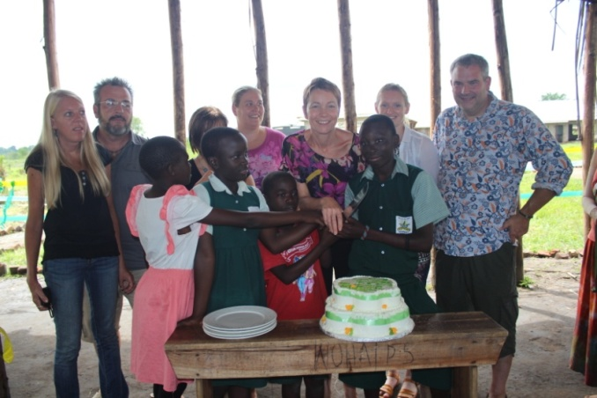
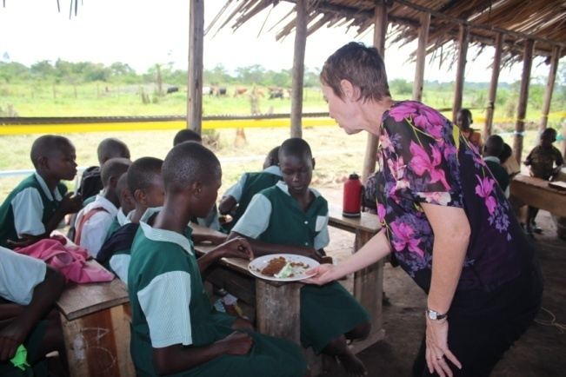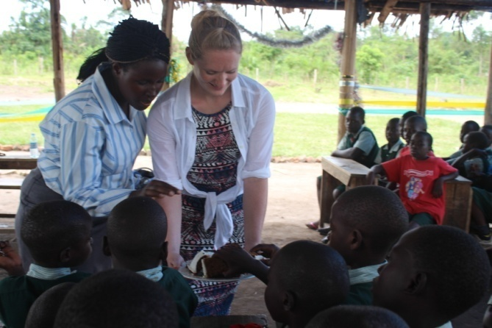
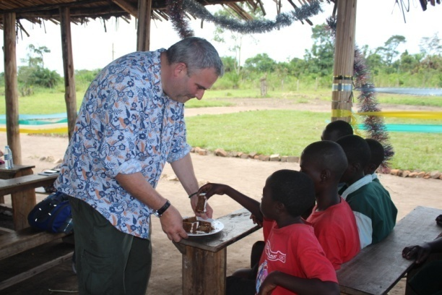
The mime was a great summary of the lives of children of prisoners and what they go through before WOH gives a helping hand.
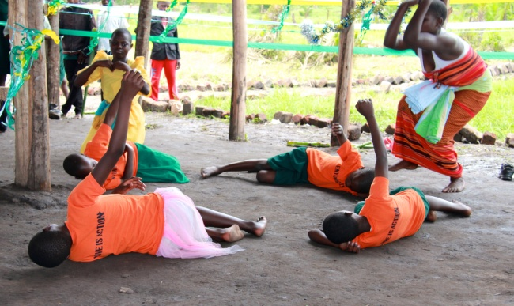
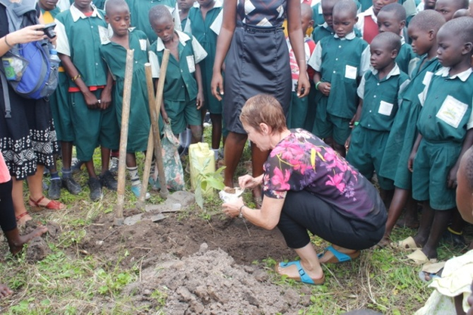
Lunch was served with the children
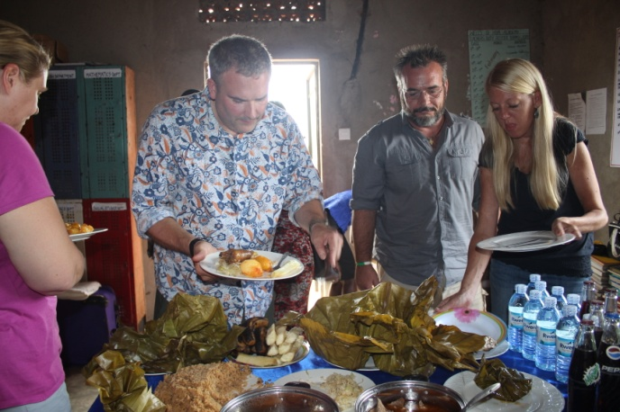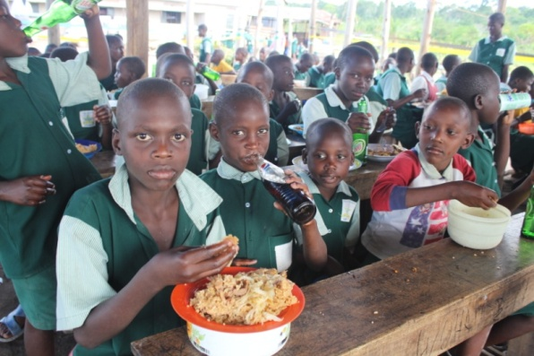
After Lunch, there was a one on one session and group discussion, were the participants shared and talked with the children
We had a group of 15 children, all of them being cared for by their grandparents .Dr. Sharon led this session, At first we had a general group discussion were the children shared their testimonies of what grandparents have done for them;
Peninah said that she has never met her mother so she calls her grandmother mother because she is taking care of her , Nambi N said that her grandmother has been her sole provider but because she is now sickly she cannot take good care of them ,she is ever complaining of when their mother will be released to take care of them, Rebecca said that her mother died when she was three months old and her father was already in prison ,so her grandparents took care of her up to now, she had also never met her father until she joined Wells of Hope Academy ,Ntanzi Brian told us that his mother threw him at his grandparents place when he was nine months old and his father was imprisoned .
During this session the children were so emotional so we decided to bring to an end and we started asking them questions of what they would like to be after they have finished school, some said they wanted to be Lawyers, Doctors, Parliamentarians, nurses, Teachers
After that we had a one on one session where the children interacted with the participants.

Day Four 26th September 2013
Review meeting
- The school was lovely and fantastic
- Seeing the children happy was truly amazing
- Children were so welcoming and so eloquent
- Learnt a lot of new things from the sharing with the children
- Children became very emotional while talking about their families
- The mime was very educative and summarized the whole situation of children of prisoners
- Lunch was amazing
- Managed to do everything in the time allocated
- The planting of the trees was a good thought and look forward to seeing them all grown up
- What is taken for granted , how special it is in so many places like at WOHA
- One on one session might have made the children more comfortable and share more than a group discussion
- Children need to feel the support of the people around them which is what wells of Hope is giving them
- Need to be cautioned when it gets to sharing certain information encouraged that wells of Hope academy is a model of good practice and it should be shared
Rebecca; next time we should spend more time with the teachers and get to know how it is for them to teach these children, what approaches they need, get to know the children and what keeps them going amidst such experiences
One on one with the children would have been appreciated though the group discussion was good.
The relationship between the secretariat and the children was amazing and yet they are always so far off but that shows the dedication of the staff.
Group discussion with the children was appreciated
Next study week, we should look at having 2 days at the school, maybe an overnight stay so that the children get to know the visitors and feel more comfortable with them
Meeting at Kawaala College School
Meeting with the teaching staff
Self introductions were made by all the participants to include the teachers at Kawaala college school.
Sarah introduced herself and talked about how she started helping children of prisoners, once a teacher and touched by the story of her children whose mother had been imprisoned and from the time she visited the mother, her attitude towards these children changed.
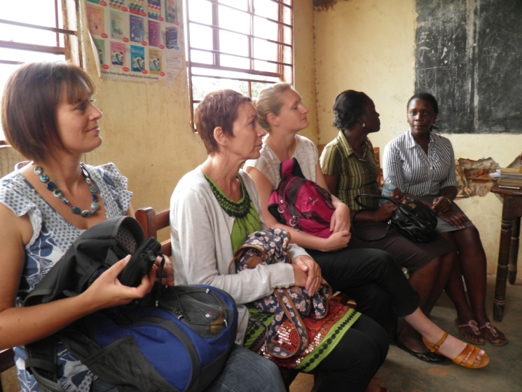
How can teachers offer support
- Offer compassion
- Reach out sensitively
- Remember that a parent is still a parent mindless of the situation they are in once, the parents know that their children are in safe hands this reduces re offending
- Through the positive attitude of the teachers, it reduces chances of intergenerational crime
Teachers are the most important people in children’s lives as children spend more time with them than they would spend elsewhere in the community.
Teachers need to understand that prisoners are human realize that the behavior they see in the children, maybe through rebellion, withdrawing from society, it is because of the situation back at home.
The situation of COP at Kawaala College School
The Head teacher and his staff sat as a team and looked into how to handle these special children as they do not come from the same situation as other children and they decided to;
- Find different ways of punishment so that the children do not feel bad and start blaming their situation because of being a child of a prisoner
- Softened punishments in comparison to other children
- Meet and talk to them as a group, counsel them constantly
- Constant communication with people at the office and the head teacher
- Don’t tell the other children about the situation of children of Wells of Hope, it is a secret amongst the teachers
The children are very well behaved and they do not form a group or do they mingle with others
They interact freely with others
Some are leaders at school
How to handle when other children get to know that these children are children with parents on death row
That situation has not happened yet and so they need to think about that incase it is to happen.
Children need a trusted friend; children need to have strong self esteem and building up their confidence
If a child tells a teacher something, the teacher should be discreet unless it is dangerous to the child, then he/she has a right to tell other teachers about the situation
What to do with the community if they know
- Sensitize the community
- Remind the children that it’s not their fault and that they are not alone
- Awareness raising days to educate all children
- Students abuse each other
- Children trust only the HM
What do we tell our friends when we go to visit our parents?
- At times we say we have gone for a tour
- Other times we have some competitions to attend
- We told the other students that we are a family so we need to move together, sometimes if our friends are left behind, they get to ask why they have not gone which is very hard to answer
- 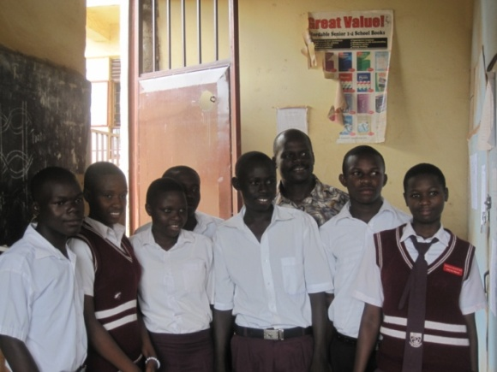
What do you tell your friends about your visitors
- We have gotten a visit from our sponsors
- We have gotten a visit from our adopted parents
- We have gotten a visit from our aunties and uncles
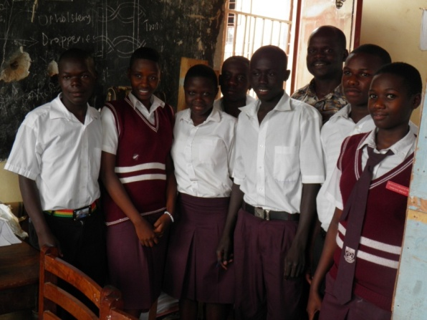
Day Five 27th September, 2013
Family Tracing
The study week participants were divided into two groups, one group headed to eastern Uganda and the other group headed to western Uganda
Group A
First Family……………………………..
The first group went to visit a family of a grandmother in Gobero…….., she is looking after her grand children from her different children including those whose mother is in prison, Wells of Hope has two of her grandchildren.
She was very happy to receive the visitors, and was glad that some people had come to check on her.
She digs to get some money to support her grand children; one of her grand children was very sick and had returned from school.
She has a small house which she constructed when her previous mud house was almost going to kill her and her and children because it was bending and falling from the rain. She sold off the cows she had and bought the building materials to construct the house, unfortunately when that money was all used up that was as far as she was going to go with the building of the house. Currently they sleep in a shelf house, with just bricks and a roof; there are papyrus carpets to act as windows and doors in the house.
This poor situation does not stop this grandmother from being happy and smiling, from being so warm and welcoming to her visitors.
She says she has so many needs and would love to go and visit her daughter in prison but because she cannot afford the transport she fails to go there but she is always glad when the children come back home with stories from their mother and in that case they can always keep communicating through the children.

2nd familyMaddu(please fill in for me the names…………………
The grandmother was ever so excited to receive her visitors infact she mistook them for a friend of Wells of Hope who had sent her a present at the beginning of the year. She was very excited and happy to get company.
She sleeps in a one roomed mud thacted house, that is where all her grand children used to sleep with her before WHO took them on. She has to look after her son’s cow, which she takes out in the morning to graze, she was very happy to hear from her grand children. Steve showed her beautiful pictures of her grand children WOHA, to include, Agness, Rose and Sarah. They told her how well behaved they are and how they love to dance, a trait they must have gotten from their grandmother.
She was even more excited when she heard from her daughter in prison, and that she was well even her grand child who is with her mother in prison that she is well and growing up very steadily.
What problems do you find
There is a lot of loneliness, I have so many neighbors but they all just greet you and they continue on their way, none of them ever sit down to get time and talk to you, my grand children are in school and I miss them so much but I am happy that they are getting good education to help them become better people.
I also do not have any financial support; I depend on the produce from the farm. I used to have chickens but they are all gone now.
She gave a grass basket to the visitors and asked them to take the basket to her friend who also comes from their country.
She asked everyone to send her greetings to her grand children at WOHA and also to her children in prison whenever they get the chance to see them, though she would love to go and visit them, she does not have the financial support to do that.

Group B
This group was led by Marjorie, they first visited a family in Mayuga, this family is of a grandfather who is 74 years old, the status of the family is so Appling, three of his sons are in prison on death row and his wife passed on. By the time they reached this family the children had not eaten any thing, the children looked malnourished and sickly, the grand father too had a tooth ache but had not gone to the hospital because he lacked money to pay, he said that the children just survive because he doesn’t have money to take them to the hospital .This family lives under absolute poverty.
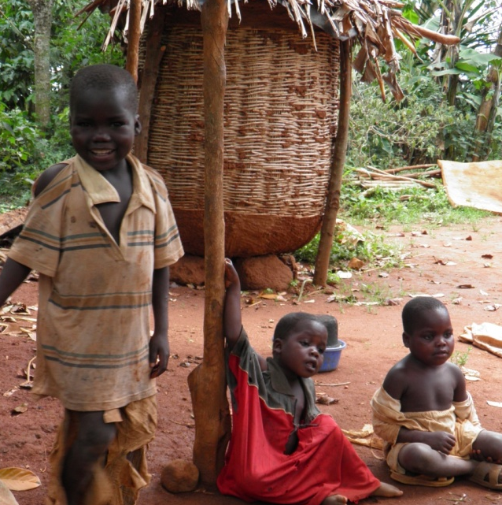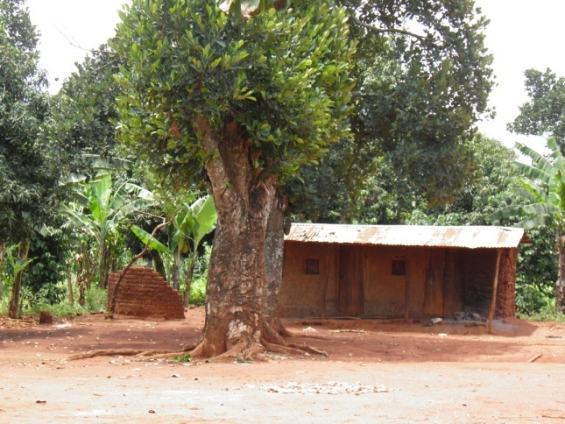
This grand father yarns to visit his children in prison but lacks transport to go there, he also wants his house to be renovated because it’s almost falling .At the moment we are supporting only two of his children but there is need to add more children .
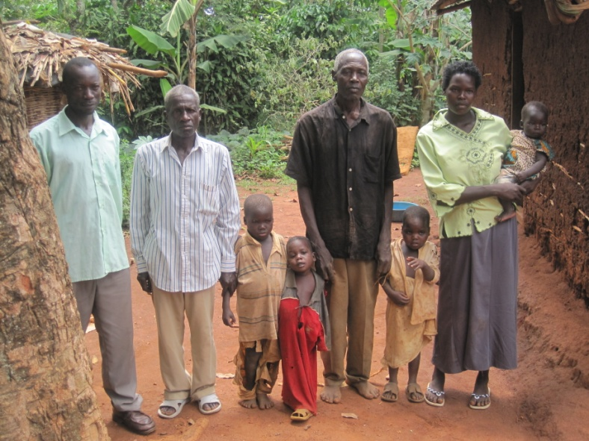

Family Two
This family is led by a grandmother, she has seven grandchildren under her care , her situation is not like in the first family because she is able to feed and accommodate the children however she is very sickly.
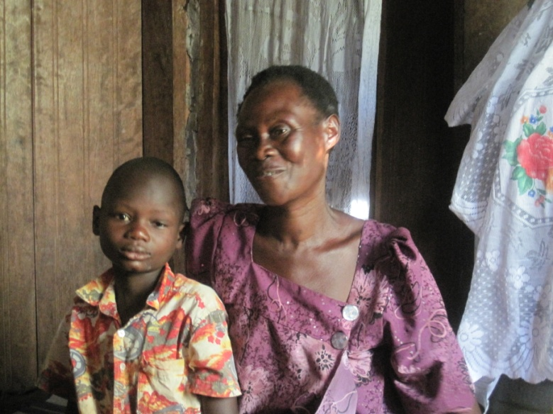
She was so excited to have us visit her home, she narrated to us of how she has struggled to take care of her g. children because their father refused to give her any support, one of the children dropped out of school and his now engaged in child labor. She used to own a restaurant but she closed it because she is sickly.
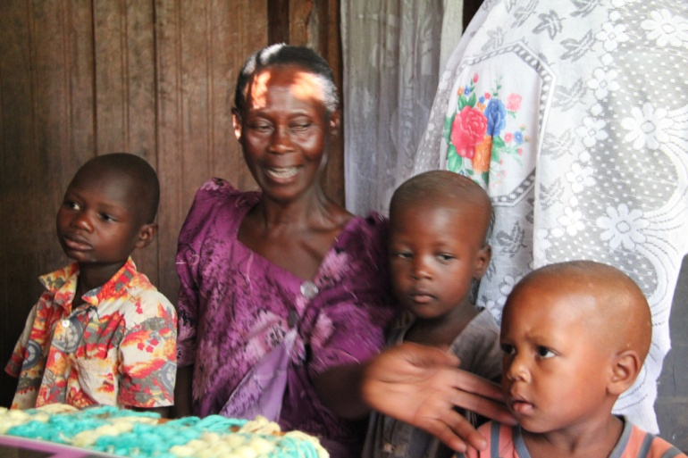
Review Meeting
Though the day had been long it was splendid
Got the real feel of a village setting in the homes we visited
The levels of poverty are very extreme and they are very evident in the lives of the people
Most grandmothers have one thing in common their main need is company, they suffer from a lot of loneliness
The participants would like to do something for the grandmothers, they want to construct a house for the grandmother in Maddu so that she does not die because that house has fallen on her, they als want to buy clothes for the children they met in….. to atleast do something good for these children.
It’s amazing what the grandparents sacrifice for the good of their grandchildren.
Thanked WOH for having reduced the burden of dependency on the grandparents

