THE 4TH INTERNATIONAL STUDY WEEK ON CHILDREN WITH PARENTS IN PRISON
DATE: 20TH TO 25TH JUNE 2016
Theme: Empowering families while addressing needs of children with incarcerated parents
Report
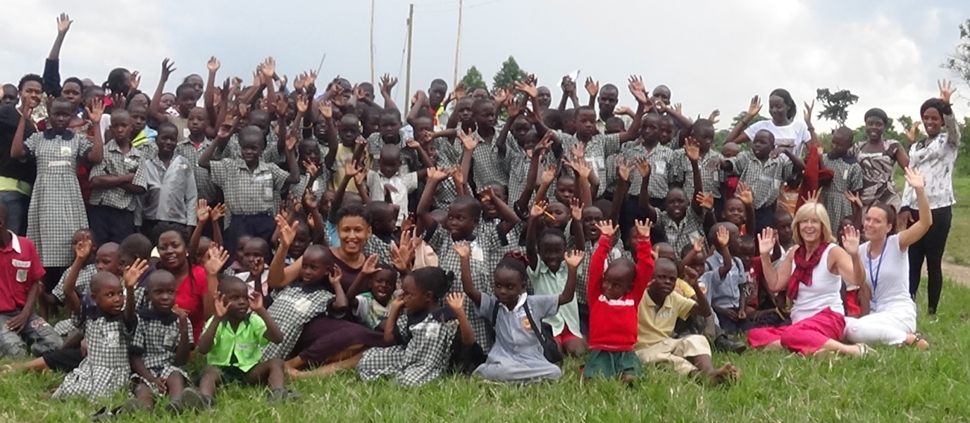

The Study week begun with a welcome dinner on 19th June 2016 where the participants where hosted to a dinner that was attended by Wells of Hope staff and the board members. The participants where warmly welcomed to Uganda, who all were visiting the country for the very first time. The board members shared their views about the country and we started sharing more about the work of wells of Hope in detail and more about the differences in our prison systems in the UK and Uganda.
Together with the staff the participants went through the program for the whole week and where really excited to share and learn more about the work that wells of Hope does with the children with parents in prison and how we are working to ensure that the vulnerable children with parents in prison get the attention and care they need.
20th June 2015-Day one Visit to Wells of Hope Office, Girls Child Network and St. John’s secondary school
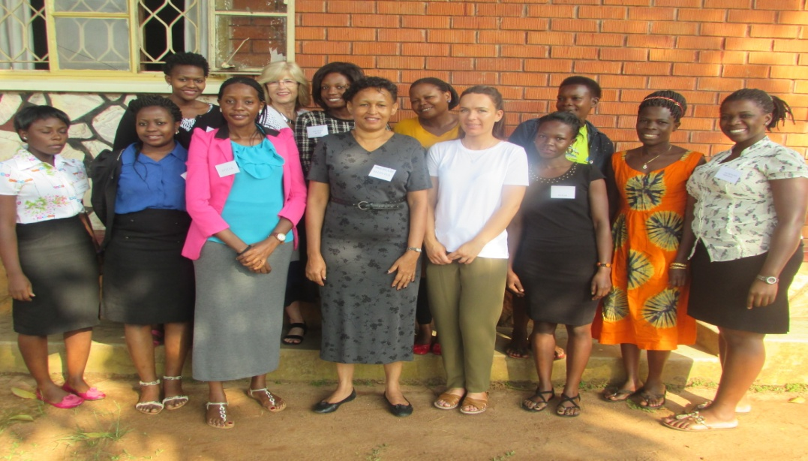
Ann and Hannah with the Wells of Hope team at the head office
The participants visited the wells of Hope offices where they interacted with the staff at the head office, finding out more about the work they do and sharing in detail about how best we can improve on our work. The participants later went to the Executive director’s office where they had a short meeting with the Director and projects coordinator. They shared more about the work of wells of Hope; they watched a short video summarizing the work of Wells of Hope.
Comments
- Ann was very moved by the presentation and was very emotional and wanted to find out if it will be ok when she gets very emotional especially when she is meeting the parents in prison and the children
- She was informed that emotions where fine and as long as people where informed that they were happy emotions and not sad/pity emotions then it was ok
- Hannah was very impressed with the work being done b Wels of Hope and was over whelmed. This is mainly because she had though that we mainly worked with children only but was very impressed how we are going around the different needs of the child and trying to address them
- The participants also observed that though there is a lot we would like to do we are greatly limited by resources
The participants went and met with the mothers/beneficiaries from some of the different activities that Wells of Hope is involved in. The mothers shared with them about the different activities they have been involved in to include the Hope SACCO, the liquid soap making classes, entrepreneurship classes and the tailoring classes. Which the mothers have benefitted from greatly. The mothers showed off some of the uniforms that they have been able to make and the participants were informed that this is the very first business the mothers involved in tailoring are doing and after wards they will get outside tenders from different people to make clothes and uniforms and they will be earning a percentage of the uniforms they make.
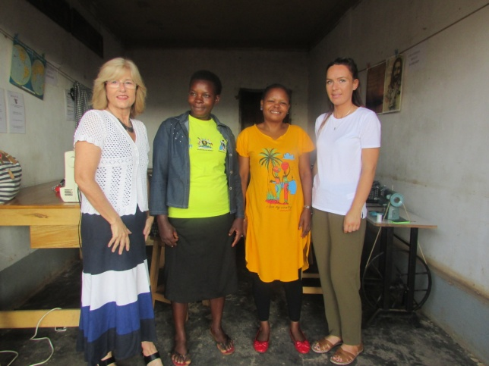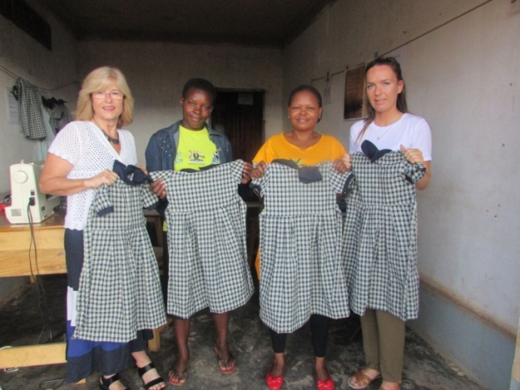
Ann and Hannah with Annet and Hadijja some of the mothers doing tailoring with the uniforms they have made
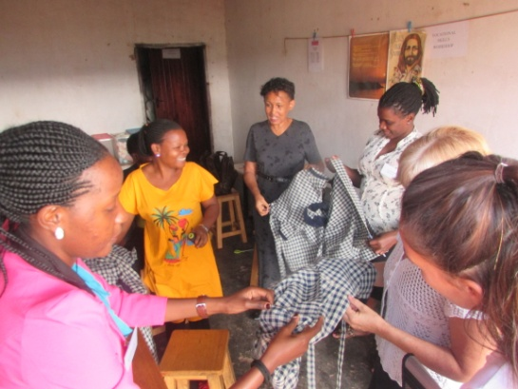
The mothers showing off some of the uniforms they have been making
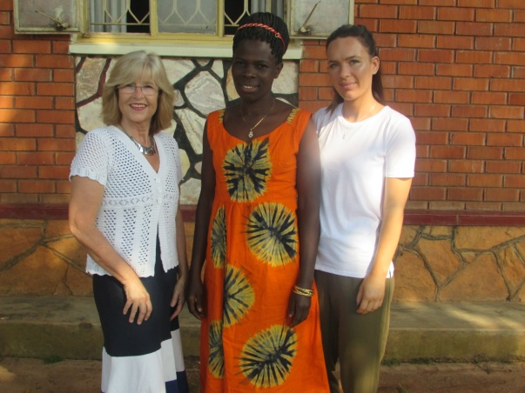
Anna and Hannah posing with Susan in a dress she made herself
From the offices the participants set off to the prison head quarters to meet up with the prison personnel. In that meeting they met with Mr. Owini Anthny, Asinjah Apollo and Akankunda Apollo. These where the representatives from the prison department who met with the participants.
The prison department shared about the good and constant work that wells of Hope has been able to do in prison since they started. They appreciated the fact that Wells of Hope bears in mind the security concerns of the Uganda Prison Service and requested that services offered should further be extended to more people in prison who need the support of wells of Hope.
A brief was given about the Prison service structure and especially the social welfare department which works directly with Wells of Hope. Children with their mothers are supposed to stay in prison until they are 2 years old but in many cases the children stay up to almost 4 years because they do not have a next of kin who is willing to take on the children. They further explained that men being the bread winners in the communities when they are imprisoned the family stopped receiving any sort of support. The children drop out of school.
The following were observed
- Longer sentences are being given a challenge to the family
- Less consideration for children when parents have committed capital crimes
- Prisoners do some odd jobs and save money which is supposed to support them when they are out of prison
- There is still a negative attitude towards children whose parents are in prison in the community as a whole and hence a very big need for advocacy in that area
- Children with parents in prison are not catered for under the government policies when considering vulnerable children
- Though there are probation officers, they are not very effective because of the low funding and the low numbers of probation officers per district
After the visit to the prison head quarters the participants met with one parner NGO of wells of Hope called the Girl Child Network. They shared with the counselors and how they have supported children with parents in prison through counseling. They were very impressed with the type of work being done though with very little funding.
Observations
- Boys too should be included in the counseling as most crimes against the girls are committed by the men
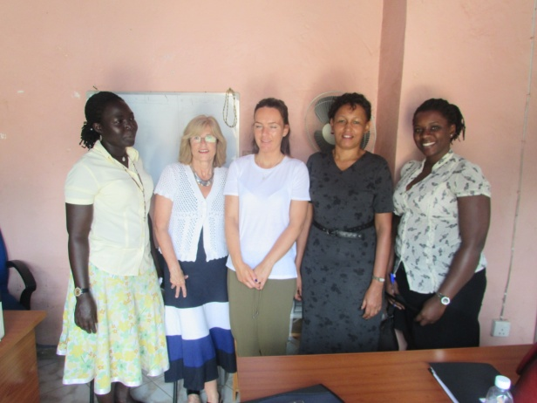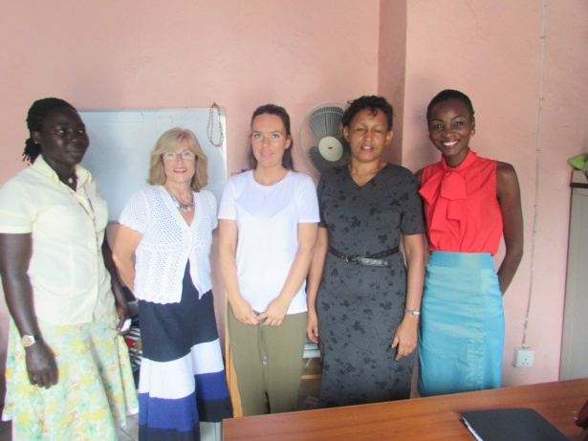
Participants at the Girl Child Network offices with the staff of GCN
Later in the day the participants went to St. John’s secondary school were they met with twelve children under wells of Hope care. They observed that the environment was very spacious and conducive for children who are learning. They met and shared with the children who happily shared with the participants how their lives have greatly been improved because of the love, care and support that they have been getting from wells of Hope, All the children were very glad that they were in school and did not miss out any classes as they used to miss out before they joined wells of Hope when their mothers would strain to support them. The visitors shared with the children about their home country and what they had come to do to learn and share with the children. The children shared their dream careers which included being doctors, surgeons, nurses amongst others and they were encouraged to read hard and that they would definitely succeed.
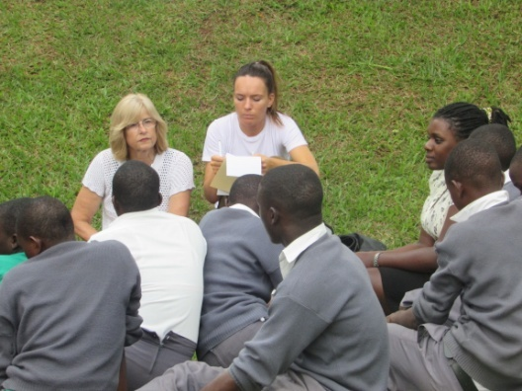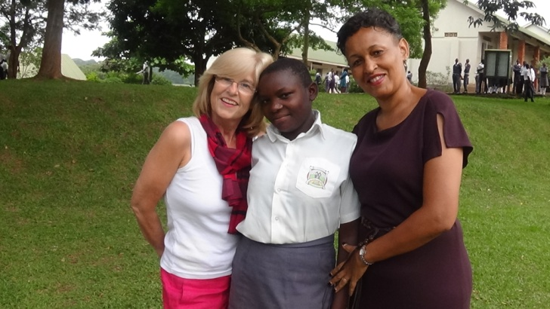
Participants sited in a circle sharing with the children at St. John’s secondary school
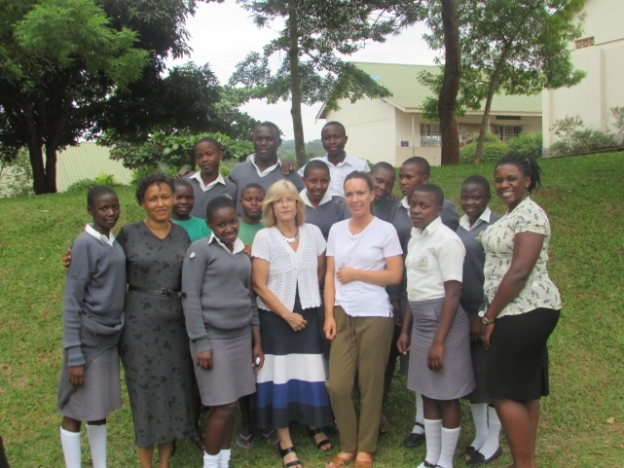
Participants in a group photo with all the children of wells of Hope at St. John’s secondary school

Day Two- Visit to Luzira Maximum security Prison Men(Condemn and Boma Sections) and Women Section
The second day the participants went to the prison, to meet and share with the parents of the children under wells of Hope care. They started off by visited those parents who are in the condemned section. They met with eleven fathers whose children are under wells of Hope. The participants were warmly welcomed by the fathers who shared their testimonies and stories with the participants. They informed them about how it was so hard to leave their families and mothers behind knowing that the families had no one to look after them. They were very thank full to wells of Hope for coming in to take on their children and they now have a lot of hope in those children under wells of Hope in comparison to all their other children who stayed with other caretakers. The parents have confidence that the children will become a success and good citizens in future.
They appreciated the work of wells of Hope stating that Through Wells of Hope support, they manage to see their children once every 3 months which was not the case before as their families used to stay very far and could not afford to take the children to visit them every other month.
They were further thankful that wells of Hope even managed to bring the caretakers of the children their mothers to visit them in prison something that had never happened before.
Some comments and observations
- The fathers had gone back to school so that they can acquire a qualification
- The fathers were very excited that their children could even speak better English that them
- They also requested that more children could be taken up so that they can help support their families
- They requested that their spouses and grandmothers who are looking after the children could get some business start up capitals so that they are able to look after the rest of the children who are not chosen to go under the Wells of Hope sponsorship project
We then proceeded to the Boma section where the participants met with the other fathers/beneficiaries of Wells of Hope. The participants were entertained with some traditional songs and the fathers also gave their testimonies about the work that wells of Hope has done to support them. One father was quoted saying, he used to worry so much with the fear that one day he will see his son being brought in prison by guards for having committed a crime.
They further explained that they used to worry every day about the lives of their children back home but where very glad when wells of Hope came in to support the children. And not only are their children being supported but they also get some porridge for those inmates with HIV&AIDs and also spiritual uplift from volunteers of Wells of Hope.
Comments
- The fathers also went ahead to request that more children can be taken up by wells of Hope as they have many of their friends who are daily worried about their children back home
- They also requested that some attention be given to their mother/ the grand mothers who look after the children they leave back home
In the women prison, the participants met with one mother who is the only beneficiary of wells of Hope at the women prison. They shared with her and she was very grateful that wells of Hope had taken on her children when she and her husband where imprisoned. The children were staying with their grandmother who was very frail and sickly and could not support them properly and she was very grateful for that. She further explained that she was very glad when she heard that Wells of Hope would be taking on her daughter who was born in prison but was 4 years now because there was no next of kin who could take the daughter from prison. The participants shared with the mother and asked what she does in prison to keep her busy. She explained that she weaves mats and baskets which she then sells to make some money to prepare a meal for her children when they come to visit. She explained how the visits uplift her soul and on departure emphasized that her children should keep in school and read hard.
Observations
- The participants were awed as to why both parents could be given such harsh sentences leaving the children with no one to look after them
Day Three-Visit to Wells of Hope Junior School
The participants arrived at the school at 10: 35am and they were given a warm welcome by a team of the school scouts. They were then led to the Headmasters office where they interacted with him and then signed in the visitor’s book with the help of the Headmaster. He gave a brief introduction about the school and his role as the Headmaster of the school.
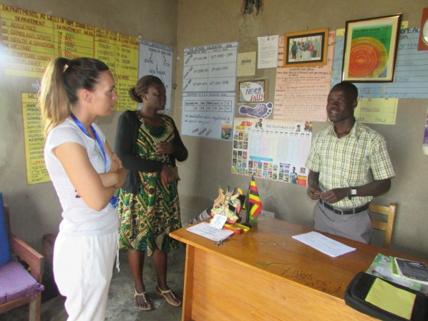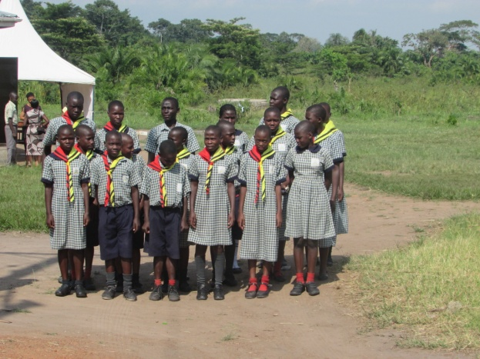
Ann being welcomed by the head teacher and on the left the scouts club welcomung visitors
He then with the help of the scouts led the visitors’ tour around the school. They first went to the Boys dormitory, they also met the matron of the school and they asked her about the general behaviors of the children. From the boy’s dormitory, they went directly to the girls section and those that get malaria get treated from the school sick bay. They were then taken to the sickbay were the children getting treatment when sick. The Headmaster explained how the sick bay works. He also talked about the Nurse who comes in every twice a week
The participants touring the dormitories and school sick bay
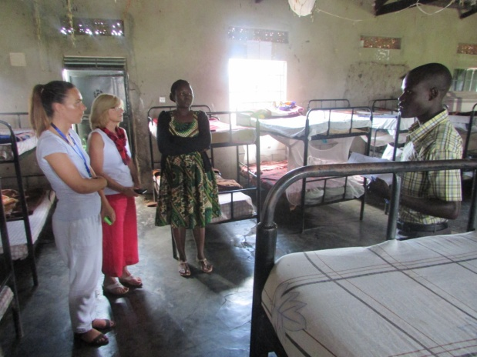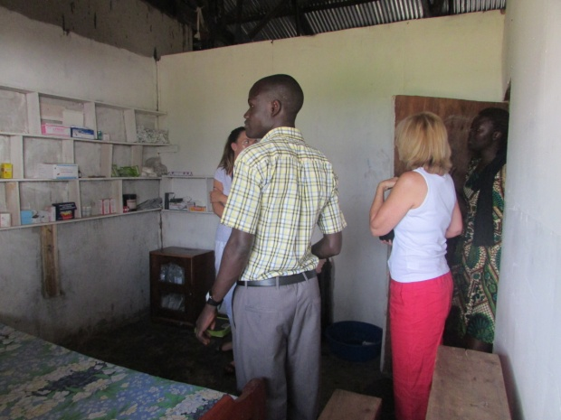

Major issues noticed
- Lack of mosquito nets that lead to cause of malaria
- girls lack buckets that they use to bath and bathing materials too
With the help of the scouts together with the visitors proceeded to the farm. They first went to the poultry house and then went to the cows but the cows had been taken to feed at that time, so they did not have the chance to look at the cows .they then went to the pigs though the pigs were being treated. They were amused by Abraham who happens to be so big. And they asked how much it would cost to build a bigger one and Marjorie estimated 6m.
Participants and the head teacher touring the piggery unit
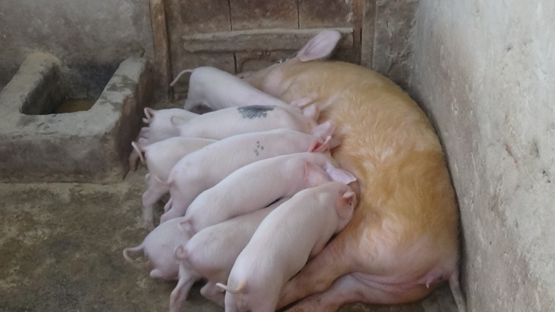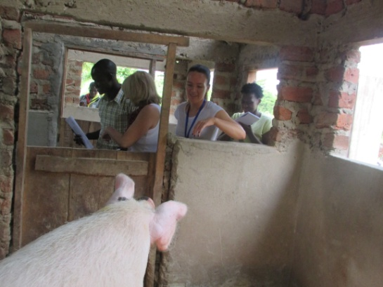
Major issues noticed
- the piggery house is too small
The participants were taken to the kitchen. They met the cook and asked about the meals and what meals are prepared for the children. Then they were led to the Wall of appreciation where names of those who have given a hand in helping the children are written. This Wall of appreciation was put up as a way of thanking them and because at times there is nothing we can give them as a ministry. The visitor also recognized some of the names on the wall of people they know.
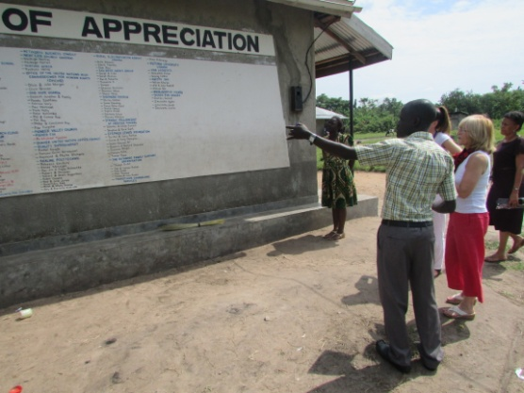The participants looking at the wall of appreciation
The visitors then went to the Classes they started with primary three and two. The two classes had combined to present one exhibition with the help of their class teacher. They welcomed the visitors and introduced themselves and then went ahead to explain. There presentation was about different types of soil and how it can be used. They had creatively molded some items like pots and others. This presentation was done by Apolot Catherine. After their presentation, the visitors introduced themselves to the children and thanked them for the great work done and went to the other class.
Catherine presenting to the participants the work of P.2 and P.3
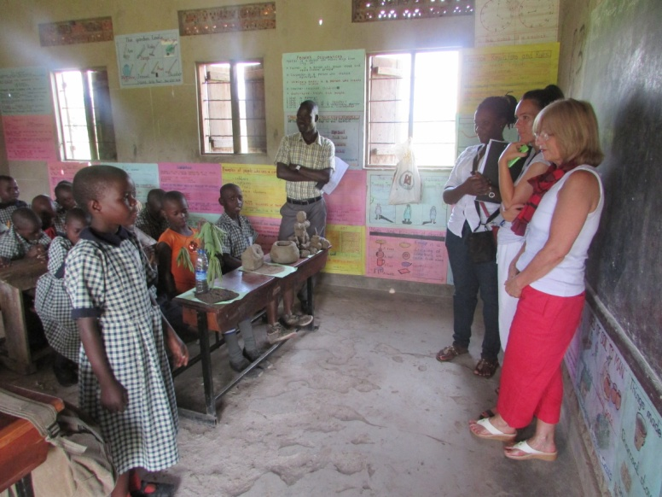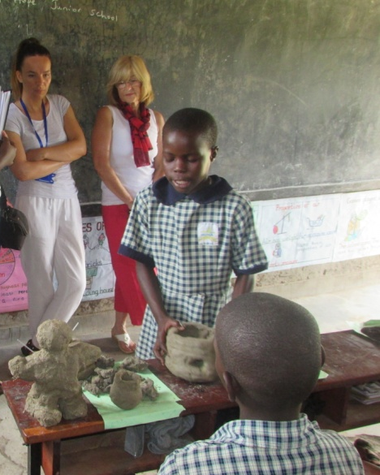
We then went to Primary one, the children were happy to see the along waited guests, they welcomed them and started right away with their presentation. They were telling us about the types of garden tools and what they are used for in the garden, these included hoe, pang and others. The visitors also introduced themselves here to the children.
P. 1 children presenting to the participants
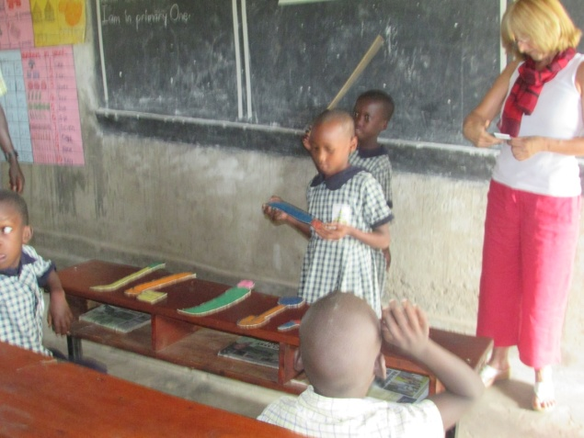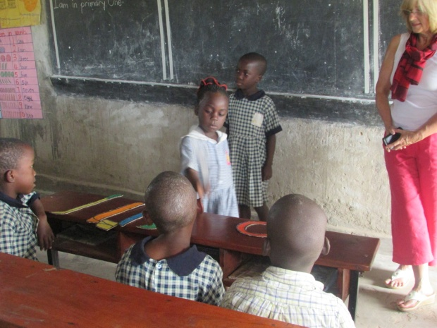
It was primary six that was visited next, here the children welcomed the visitors and then did their fraction exhibition of oranges that were cut into different fractions. The exhibition was led by Musimenta Catherine. Then the Visitors were taken to the nursery section. The children here were found drawing pictures and shading. They were really happy to see the visitors; they sung some nice songs that even the visitors danced along with them. These toddlers went ahead and expressed their love to the visitors by giving them charts that had special readings on them. This moment was really touching full of love and gratitude, it was a great moment in the nursery section.
P.6 children presenting to the participants
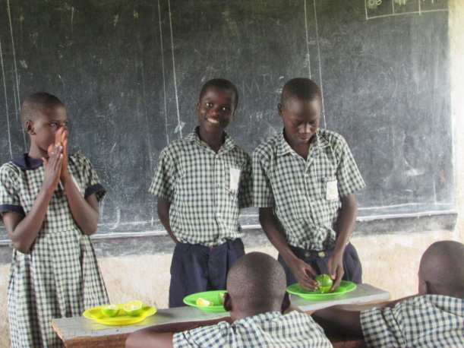 P.6
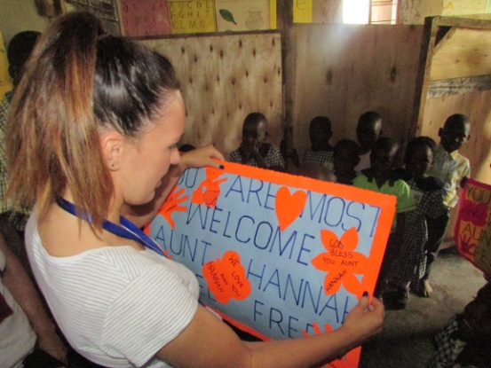 mmmmmm
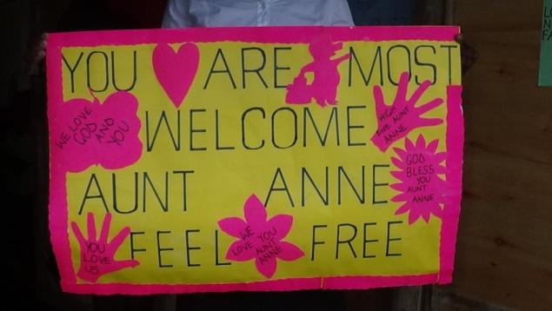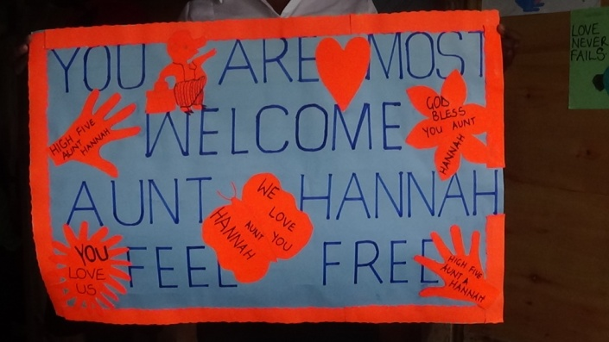
Art work done for the participants by the kindergarten
It was time to move to another class and this was primary four and five they had both combined their presentation together. They told a story of how long ago people live and this was demonstrated to the visitors. They wore leaves on them as clothes and they made a house made out leaves and sticks in the class and they also showed how boys/ men went hurting for animals as a way of getting food as the girls went to collect firewood used for cooking the food that would be brought by the boys. The meaning of this exhibition was to show that even if these people went through tough times, they had hope at the end of the day.
After having that wonderful story, the visitors moved to the last class which was primary seven, in this class the children welcomed the visitors and the teacher of this class introduced himself who is Mr. Christopher. Rebecca was the one heading their exhibition, these pupils unlike other classes; they had organized their presentation outside class. They were creative that they drew a map of Africa on the ground using stones; they also wrote the names of different continents using the same stones. Rebecca went ahead and explained the map to the visitors; this was both educative to everyone who was there and both interesting to see. The visitors were really impressed with the presentation and it was at this moment they introduced themselves to the children of this class.
Presentation by P.7 about the geographical location of their school in the world map
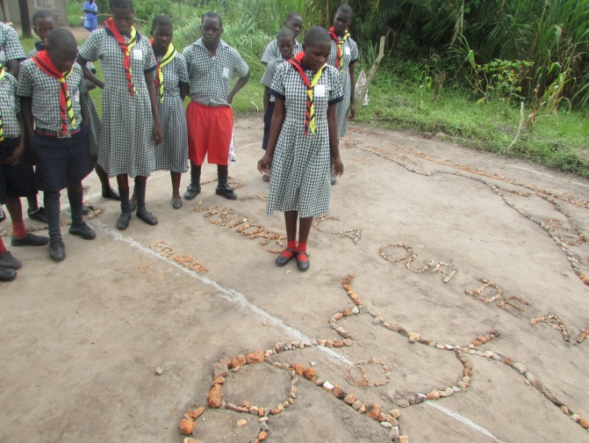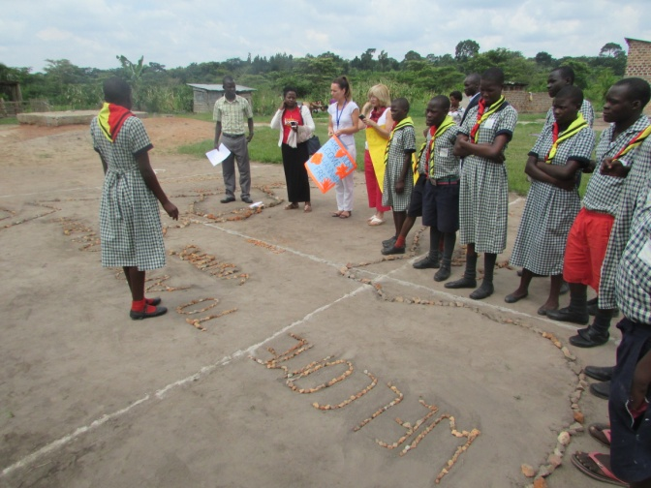
The Visitors were led to the assembly ground where the scouts hoisted the flags and sang the national and school anthem the scouts recited their scout anthem, recited their pillars of the scouts and then the national anthem followed by the school anthem and then a prayer was said.
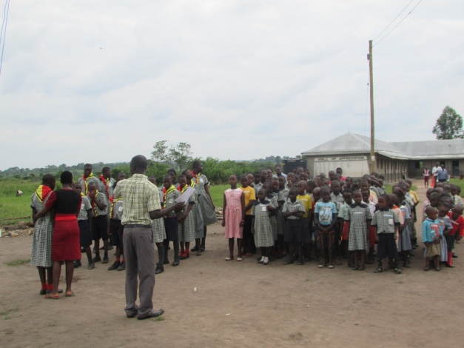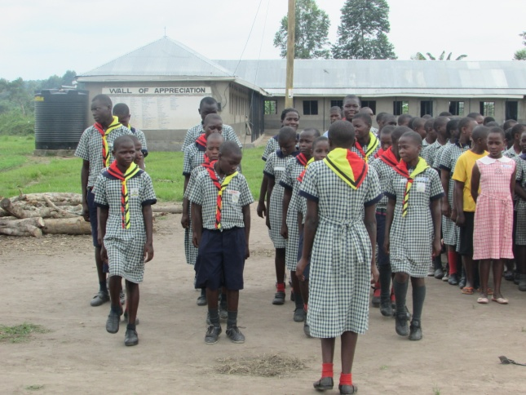
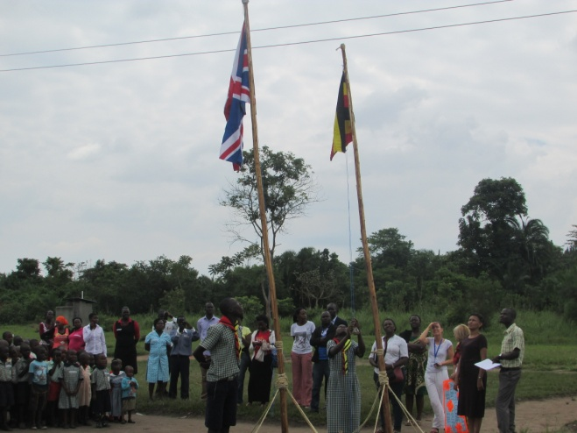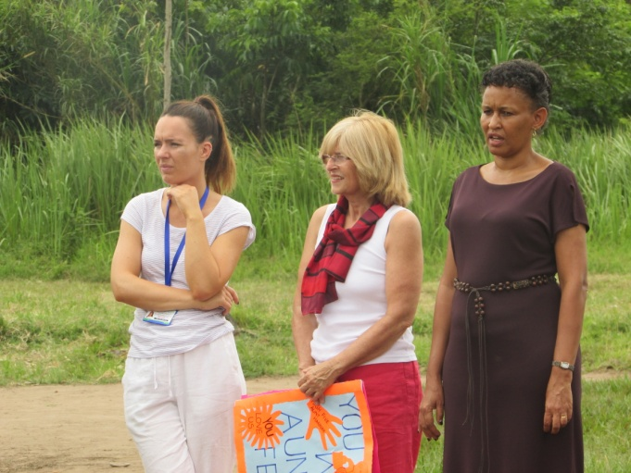
The scouts team leading the opening ceremony for the day and hoisting the flags
The MC for the day a child named Carol took the time to thank the children for the great exhibitions they had presented. The praise and worship team was called upon to lead the praise and worship; they also led us into prayer. After a reading from Mathew 25:34 this was read by Irene and Sara. Then Sara was welcomed to give a big a halleluiah to the children.
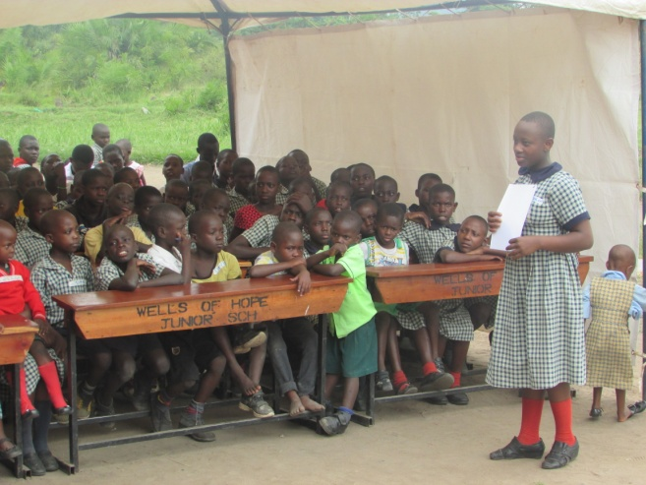Carol, the MC for the day welcoming the visitors
It was time for testimonies and three children were called a upon to give testimonies about their lives and how Wells of Hope has helped them. It was James, Carol and Catherine who gave their testimonies. They were really touching but at the end of the day they all thanked Wells of Hope for helping them. After that, the school choir was called upon to sing some songs, they did and they did it really well as they danced and sang for the visitors.

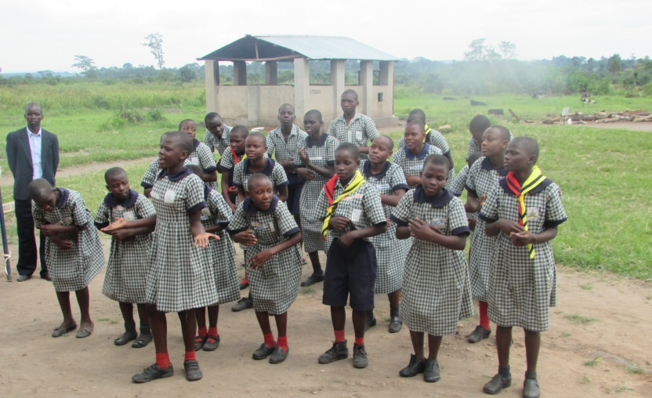

The choir entertaining the visitors with their songs

Hannah and Anne had a moment with the children where they spoke to them about education and how important it is therefore they should read their books and perform well. They also had bought the children gifts that they handed over to them

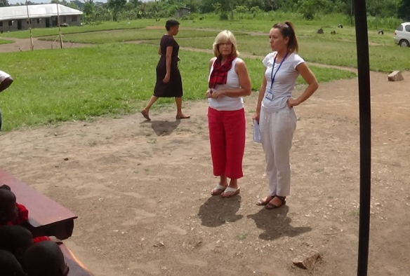
Ann and Hannah talking to the children
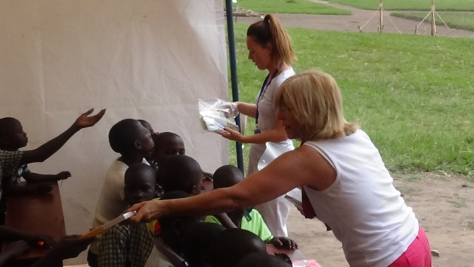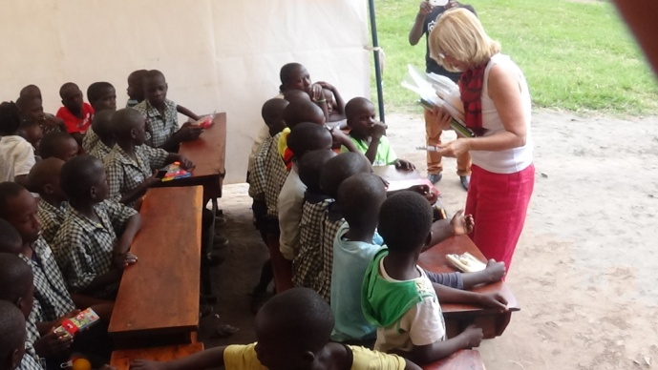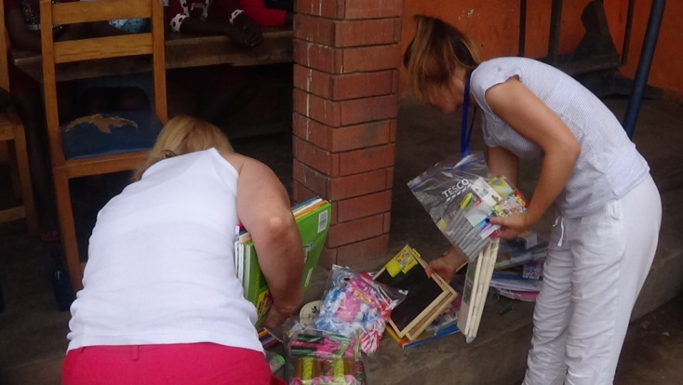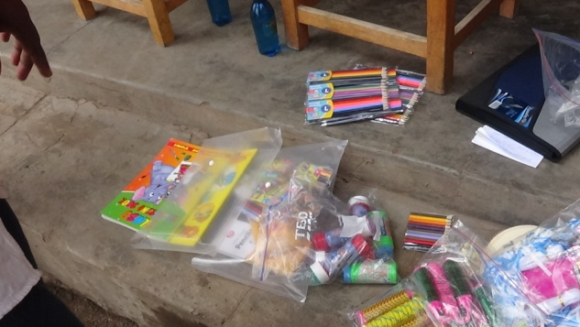
Ann and Hannah giving their presents to the children of coloring books, pencils, coloring pens amongst others
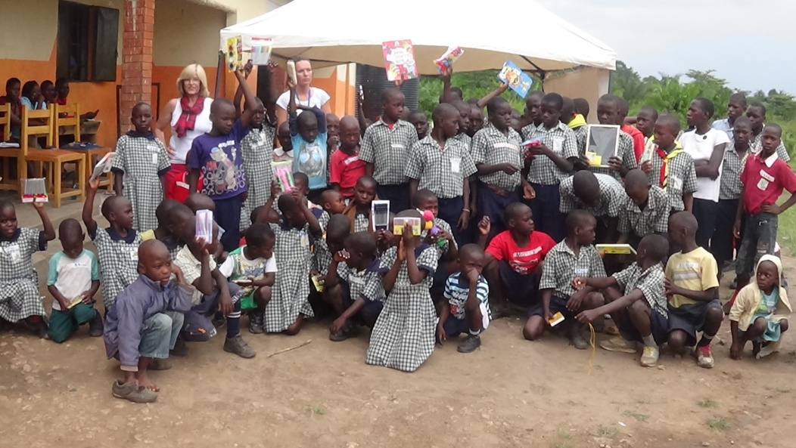
The children pose with their presents
The children were divided into four groups with different adults and they all played different games. Hannah and Anne’s groups, one of the games that were played was the game called Take Chain, the children liked the game because they had to run around.
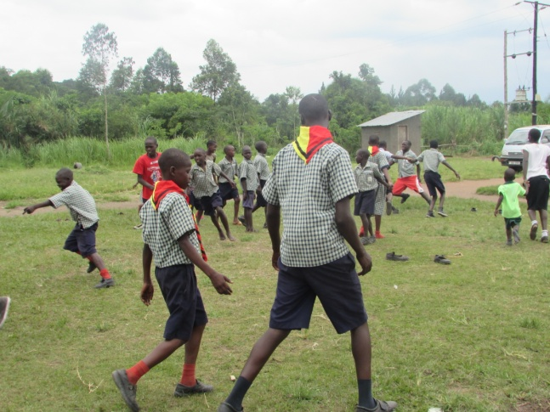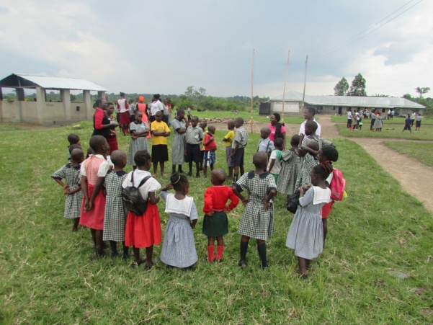
The children engaged in games with the participants

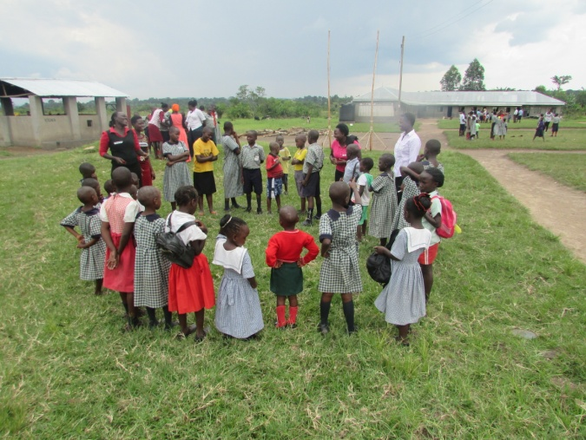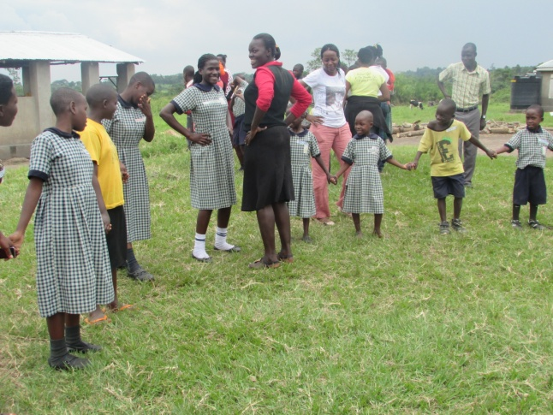
Everyone was called back to their seats as the children choir had a special dance called the kiganda dance to dance for the visitors. The name of the song is Enkyisa kyo mulokozi, meaning the Blessing of God.
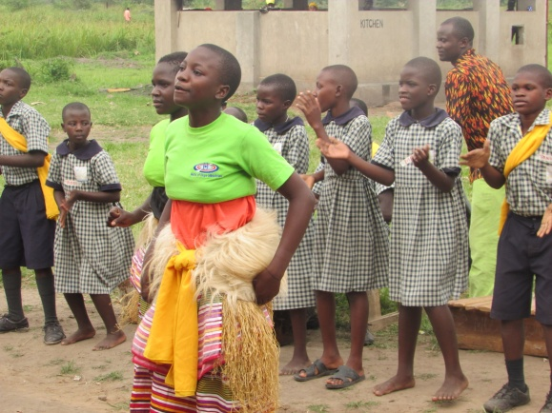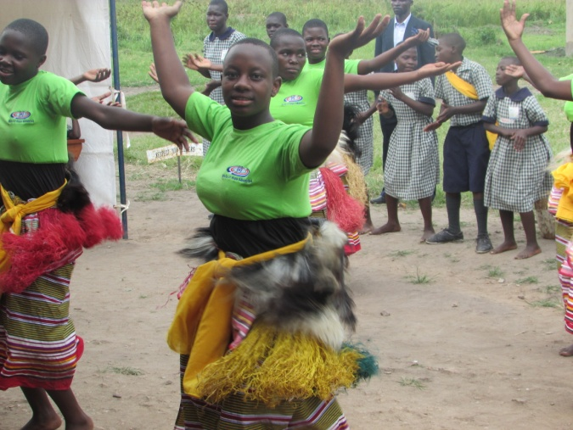
Children dancing for the participants
After then there was a moment of photos to be taken with the children and then everyone went for lunch
The participants and children having lunch
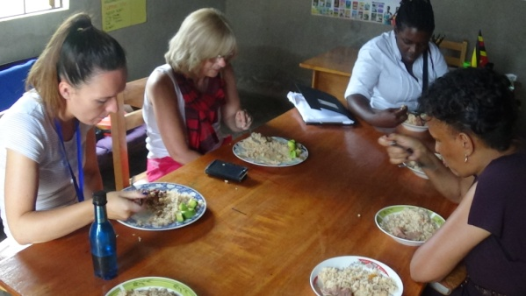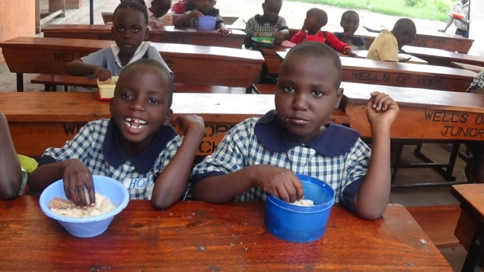
Hannah and Anne interacted with the children after lunch and they also took photos with the children during that time. After that the Visitors had some time off from other children with Carol, James and Rebecca in the Headmasters office and a few questions were asked from these children. These were what their best subjects is, How life was like before joining Wells of Hope, Do they get to visit there other relatives while at Wells of Hope, and how do they spend time away from class. All the three children responded well to the questions that were asked. At this time Hannah also shared with the children about her son who loves mathematics so much. It was a good time for both of them sharing to the visitors.
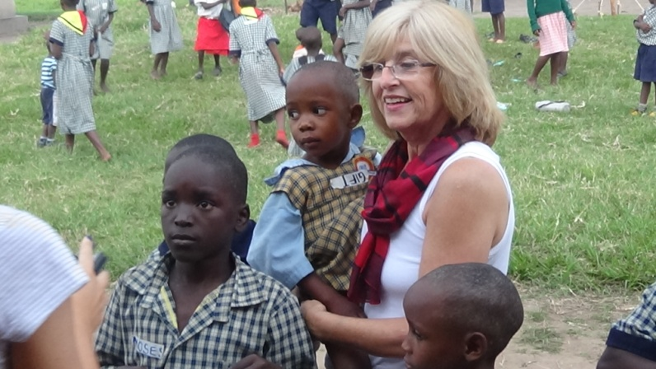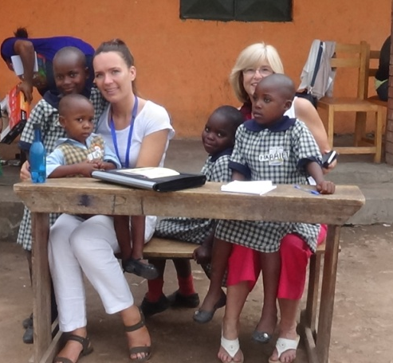
Ann and Hannah playing with the children

Day Four- Visit to Makerere High school Migadde
The activities for this day where for the half of the day and the rest of the day was a tour day within Kampala.
In the morning the participants went to Makerere High School Migadde. Where they interacted with some of the children in secondary school. They were very excited to meet more children to learn more about them and how they have changed from their previous situations. The children were very open in talking about their previous lives before they joined wells of Hope and the biggest challenge was many of them where worried that they would never get a chance to reach as far as they have reached in studying because their caretakers could not afford to look after them and some of them were forced to grow up as early one child was quoted saying “when my father died and my mother was imprisoned we were left with no one I was in primary two and I had to look after my younger sisters, my older siblings where just expressing their anger out on me and used to Cain me and abuse me. I had to work in the morning to get food for my siblings and study in the afternoon.”
The participants shared with the children about where they care from and where very glad that the children have been supported both emotionally and their physical needs addressed as one child was quoted saying “I hated my mother for what she had done to us but with the counseling and finding God I managed to forgive her and love her ”
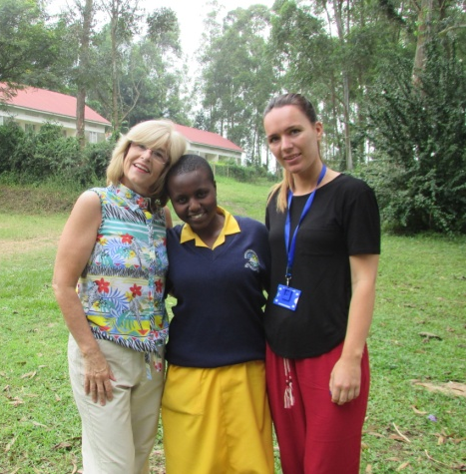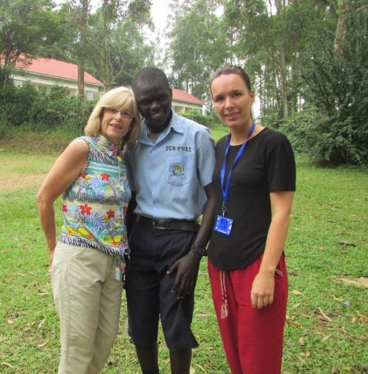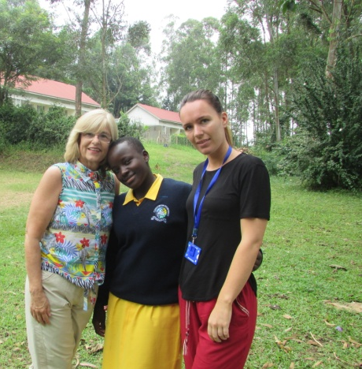
Ann and Hannah taking some pictures with some children at Migadde
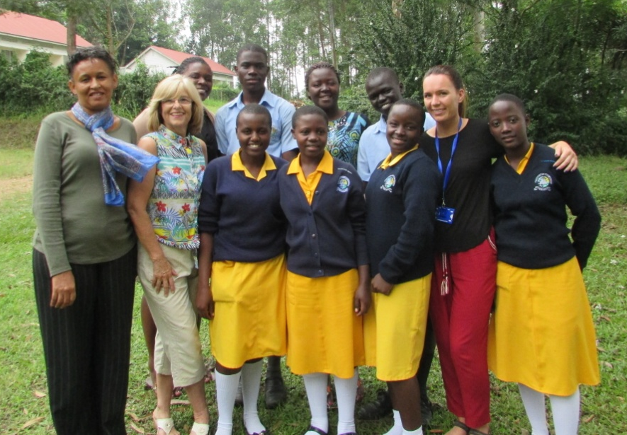
Ann and Hannah take a group photo with all the children at Makerere High School Migadde
The participants thanked the children for being so open with them and sharing with them about their challenges and all that they had passed through to get where they were at the moment. They were very glad that many of the children had dreams of becoming successful people in different disciplines when they grow up to include being doctors, nurses, lawyers, engineers amongst others. They were very thankful for the time they shared with them and informed them that with hard work and perseverance, the sky will be the limit to everything they dreamt of.
Day Five-Family visits to Mityana
On Friday 24th June 2016, the study week participants, accompanied by Marjorie and Stella (Wells of Hope staff) visited three families of children with incarcerated parents in central region (Mityana district). We were glad to find that in the first family, the children were in school and they usually visited their father in prison; they last visited in March, 2016. The children were staying with their mother who is a business lady and she earns her living by selling charcoal.

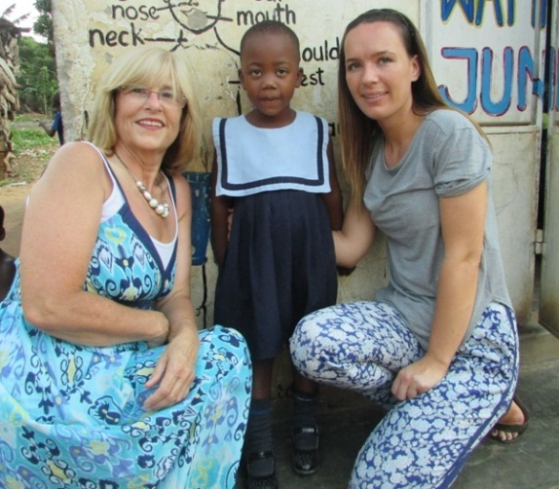
Anna and Hannah sharing a photo with Natasha (Paul’s sister) at her school
It was very unfortunate to find out that the members of the second family were stigmatized by the community they live in because of the crime the children’s father committed. The family is in deep sorrow most especially the inmate’s grandmother who is very old and weak. The family earns their living from farming.
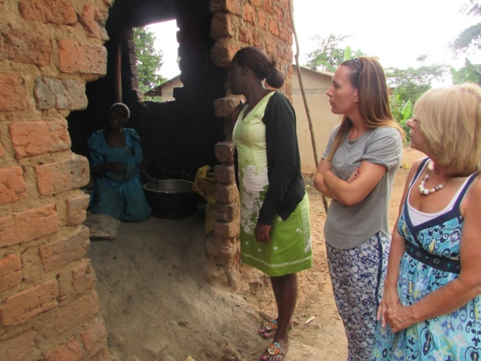
Marjorie, Hannah and Ann interacting with a grandmother
However, because they are ostracized by their community, they are forced to sell their produce at very low prices. Because of the stigmatization, the children’s paternal great grandmother saw to it that they stay with their maternal grandparents for their safety; their mother remarried.
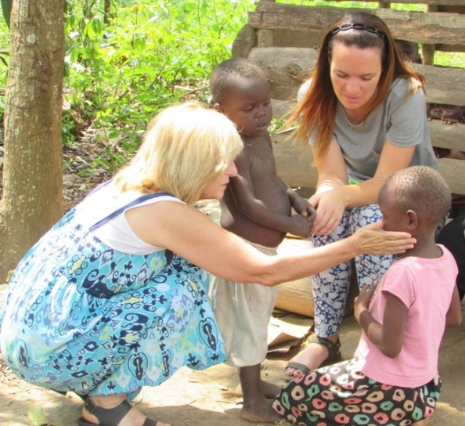
Ann and Hannah interacting with David and Annet
The children have never visited their father since he was imprisoned. Though the children looked healthy, they need support.
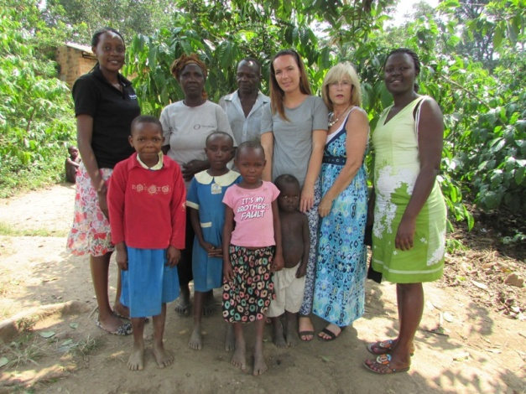
Ann, Hannah and Wells of Hope staff sharing a photo with the family
For the third family that was visited, two of the children, Simon Byamukama and Harriet Kisakye are under Wells of Hope care and have coped up very well at Wells of Hope Junior School. The family relies on the children’s mother for support; unfortunately, she suffered s fatal accident and was admitted at a nearby health centre. The children’s grandmother was left alone and was looking after three of her other grandchildren who were not at school because of lack of school fees. At the time we arrived, the children and their grandmother were in the garden looking for what to eat. The children’s grandmother is lame in one leg and uses a walking stick. She narrated that she uses the hoe handle to support her legs as she digs; and that she has to do whatever it takes to take good care of her grandchildren, because her daughter (Simon and Harriet’s mother) is very ill. It was a joy to find that the children were well looked after and looked healthy. However, their grandmother is very frail.
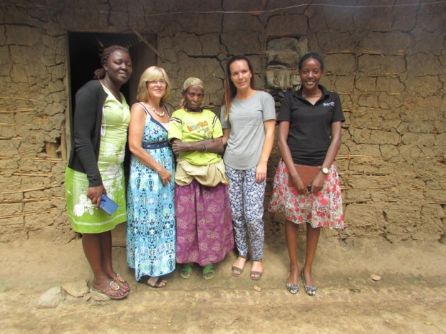
Ann, Hannah and Wells of Hope staff sharing a phopto with Simon and Harrietrs’s grandmother

The highlight of the day was the warm welcome from the families and the inmates’ relatives were very co-operative. For all the families visited, the children looked healthy.
Ann and Hannah said that it was really exciting to really get on ground and be engaged in visiting the families of inmates. During the visits, Ann and Hannah provided basic needs like sugar and soap to the grand parents and mothers.

Achievements
- Three families of inmates were visited. The directions to the inmates’ homes were direct.

Challenges
- Stigmatization by community as noted in the second family.
- The grandmothers were very frail.

Recommendations
- The children need Wells of Hope support so that they visit their father and also acquire better education.
- Grandmothers need support; if Wells of Hope does not have a project to support grandmothers, then it can partner with organizations which support them.

Day Six-Round table meeting-Report attached
General comments and observations throughout the study week (For Wells of Hope Consideration Only)
- In the next year’s study week we should consider including local participants
- Time keeping throughout the whole week should e observed
- Transport refund for local participants and beneficiaries should be considered
- Effective communication during the whole week is most important
- Children’s testimonies are improving but need to be rehearsed
- Dress code should be informed to participants before they travel especially about prison dress code
- Organize for open days for Wells of Hope
Achievements throughout the week
- Wells of Hope got a new contact at the Ugandan Christian University who can support us to get scholarships for children
- Deborah Namuyomba got a sponsor
- Local participants who attended the round table meeting assured to spread the word
- Some crafts were sold during the study week
- Children’s DVDs were sold and some sent to Ben Raikes for selling together with some crafts

