THE 5TH INTERNATIONAL STUDY WEEK ON CHILDREN WITH PARENTS IN PRISON
21ST JUNE 2017
REPORT FOR THE WELLS OF HOPE JUNIOR SCHOOL VISIT.
- Introduction: This report shows the program and activities that were carried out during the visit at the junior school on the 21st June 2017 during 5th International study week.
- Arrival at school
At was at 11:15am, Quniana together with the EDs and the Advocacy with the driver arrived at the junior school. They were welcomed by the scouts who were happy to receive them well organized alongside their teacher. After the scouts welcoming her, she was then led to Headmaster’s office where registration took place. After that, the Headmaster Mr. Charles welcomed her to the school and gave her a brief introduction about the school.
The Headmaster talked about different programs and activities that are carried out at school to mention a few these include, learning as the major one, counseling, Bible study. He also talked about other activities and which include sports with games like netball, volleyball, football and said that the children are doing well in sports though they lack materials like uniforms and other equipments for sports and a field for the children.
The Deputy Executive Director also added on that the children are encouraged to participate in those activities because from where they come from, they are not given that chance to do that since they had to work to be able to get what to eat and yet these activities are good for their health.
- Tour around the school.
Together with the Headmaster and the scouts, we toured around the school to have the guest look at different sessions of the school.
She was first taken to the farm where she saw different plats like matooke that she has never tasted pawpaw trees, potato plantation and others. From there, she was taken to the piggery house where she saw all the piglets that were born last week. She was told all the names such as Abraham. Eva the first pig at school and other pigs in there. She was really happy to get to see such big pigs.
From the farm, she was led to the children’s dormitory as we were moving there, Marjorie the Deputy ED also talked about the Jackfruit tree that its shade was once used as the learning place for the children since classes were not yet built.
Quniana was then taken to the boy’s dormitory were we met Auntie Agnes who takes care of the boys. She was happy to see her and introduced herself then the Headmaster was in position to explain to the guest some of the challenges that the boys face like lack of mosquito nets that are really needed since the weather is not favoring them with lots of mosquitoes. He also said that the children lack buckets, sandals and other basic needs.
She also saw the television the children use as a source of entertainment. The guest was then taken to the sick bay where the children get treatment when sick.
On her way to the girls’ dormitory, she passed by the tank that the children use to keep drinking water safe for drinking. We were taken to the dormitory and the room was really clean with well made beds and organized. The Headmaster was in position to welcome her to this room and also identified some of the challenges which are similar to the boys.
After that, together with the scouts and the Headmaster, we went to the kitchen were the children’s food is prepared from. In there we found the cooks cooking and they were preparing matooke that she was amazed to see since she wanted to know how it’s made. Besides that other foods were being prepared for lunch. The Deputy ED also explained to her the type of food that is usually given to the children which is posho and beans and this is used by all the schools in Uganda. As she was heading to the classes, we passed by the Wells of Hope appreciation wall where names of the people who have donated to the children are written and the children gather there and pray for them since they have nothing to give them.
- Class exhibitions
The guest was taken to different classes where the children had prepared some presentations for their guest.
We went to the nursery class where we found the children ready to sing for her and they also gave her beautiful gift that had torching word on it. She was very greatful to receive that as she was seen weeping tears of joy. She said she was going to take that to her home back in the USA. Together with the scouts, we headed to another class that had a combination of primary seven and six. These children presented a nice and touching poem about injustice, in this poem, the children expressed themselves and hope for change.
From there, it was time to move to the next class and this was a mix of primary five and four. They had a skit ready to present and this was a bout Sanitation and Health. The children really did a good job since we the viewers picked something from the skit. The skit was about the dangers of poor sanitation and the diseases it can bring to people like typhoid, cholera and others, this was really educative.
The last presentation was from primary three, two and one. Here the children made lots of interesting and they were really creative. They had waved mats, made beads necklaces from paper and also made bags out of thread. The children also went ahead and made beautiful medals from clay, these were items like pots, a hoe, a phone, charcoal stoves, saucepans, cups and animals like snakes and many more. They also went ahead and showed the guest how some of the items were made which was really a great experience.
- Group assembly
At about 12:30pm, the children went to the assembly where the scouts hosted the flags of both Uganda and America. They then sung the National anthems and said prayers then we headed to the hall where other activities were going to take place.
- Entertainment
The guest was entertained by the enyunyuzi children choir with their beautiful songs and the great poem organized with the help of the Executive director.
The guest was then called upon to give a word of encouragement to the children. She also revealed her best in the Bible which is Romans 8: 28 which were read to the children. Quniana thanked the children for everything that they did for her and also thanked the preacher Sarah for preaching well. She also encouraged the children by telling them that whatever happens in life happens for a reason, they should always be hopeful in life that all will be well.
Quniana brought the children some story books which she handed over to them with so much joy the children were happy to receive the books.
- Testimonies
Bob James shared his testimony with the children and his fellow children. In his words, “he is very grateful to Wells of Hope Ministries for the hope they have given him since he thought life had come to a standstill when his father was taken to Prison and he had stopped going o school. He also added on that at times he would go without food together with his siblings. He also had no opportunity of seeing his father while in prison but he is able to see him now through WOHM and he wants be a Doctor in the future.
Cairo is also very great full to WOHM because they have given her education together with her sister and brother who had stopped going to school because their father was in prison and their mother had no money to educate them. They are happy because now they have hope that they will make it in life through WOHM and she wants to be a journalist in future.
- Quniana sharing with the children
The guest had some time to share with the children, she painted with them and also drew with them pictures. It was a great time with her and the children.
After the above activity, she was also entertained by the enyunyuzi little choir. They were really smart with their colorful costumes.
- Lunch
Due to some delaying in the program, lunch was served late though it was really tasty. Unlike the usual, this time the children had a change in the diet as this time it was rice, meat and matooke with soda from the founder unlike the usual posho and beans.
After lunch, the children were more active and they continued, they opened this session with the kiganda dance that carried some people out of their seats like the founder and the advocacy to dance with the children.
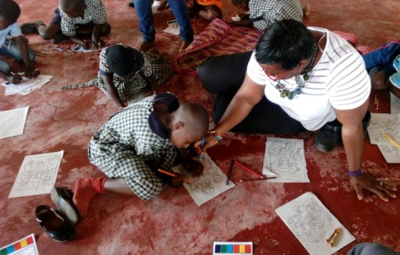

- One on one interaction with the children
Quniana had a one on one interaction, they were able to introduce themselves to her and then they also told her what they all wish to be in future. She asked them a few questions like if they believe in themselves and they all believe in themselves.
She encouraged the children and told them that they should keep in mind their dreams and that they should make them come true and that she will keep praying for them.
The children wanted to know whether she will come back and she said she will come back.
They also asked how old she is and she told then that she is 32years old. She also asked them how they would make their dreams come true incase is seemed so hard since their parents are in prison and people might not believe in them. Some of the children said they will pray, and trust in God, focus, work hard and also believe in themselves.
She also encouraged the children by telling them that she also had her parents in prison while growing up. But she told them that they should believe in themselves and that they should always ask for help.
She also added on that when they grow up, they should try and give their children a different life from what they have gone through.
The ED also went ahead and encouraged the children by telling them that they should use Quniana’s advice since she was once like them but turned out different from her parents. And also asked them not to feel ashamed about their parents in prison since they are not the only ones in the same situation.
One of the children James Bob thanked her for coming and wished her safe journey back home and hopes that she will come back again.
- Interaction with the Teachers
The Deputy Director thanked the teachers for their great work and introduced the reason for the interaction.
Quniana started by asking the teachers on how they find dealing with the children with parents in prison. The teachers replied by saying how some of them are unruly, isolated and others .She further asked them how they handle them and they said they talk to them and counsel them.
She also added on and said that they doing the right thing. She further advised them that when they are going through such times, they can try and may be let them write a letter or draw a picture on paper what they are going through so that they can express themselves since they know them too well.
She also told the teachers that they should be able to understand them because they are missing their parent in prison.
Teacher Chris also asked what can be done in a situation where the child is not responding to the above and they are misbehaving.
Quniana responded to the above and said in that situation, the child can be left alone to be able to calm down.
The ED also asked the teachers to play their part and not to feel pity for the children; they should treat the children just like other children.
The Head master also wanted to know whether children are also punished in their country and she said that they are not allowed to do that because they will be reported to police.
Quniana closed the interaction with a prayer and asked God to guide them and bless them as they do their work.
There was a picture moment and Quniana was treated to a jackfruit which was something she has never tasted.

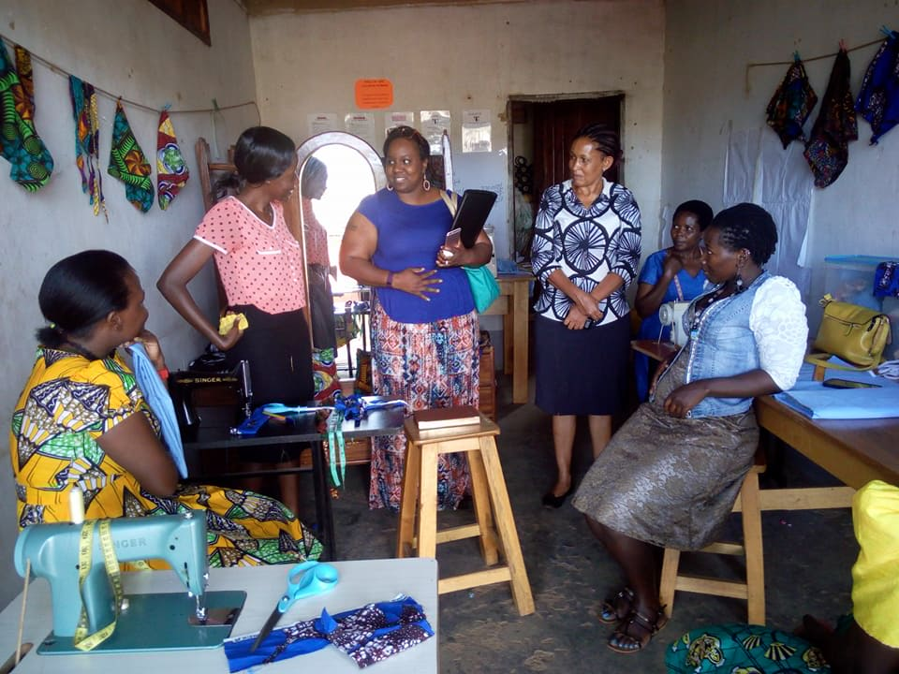
Meeting with mothers of children under Wells of Hope care and whose husbands are in prison.At Wells of Hope they are given Income Generating Skills such as tailoring as shown in the photo!
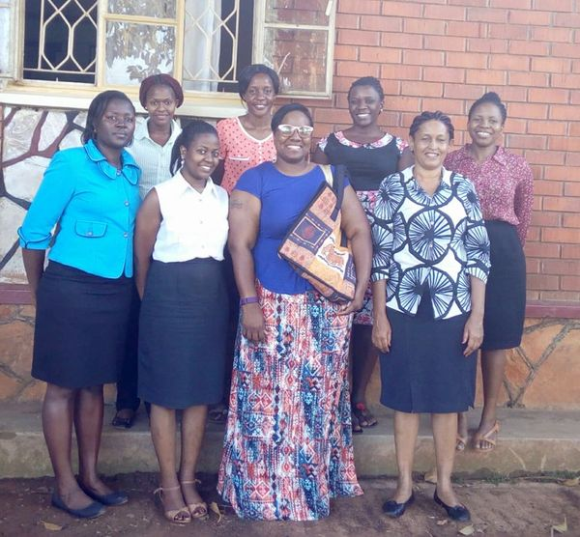
Quniana Meeting with Wells of Hope HeaD Office Team

Report about the family visits
Date: 23rd June, 2017
Venue: Mityana district
Wells of Hope represented by Ellen Ssuubi Executive Director, Marjorie Lunkuse Deputy Executive Director, Stella Nabajja Projects Coordinator and Quniana Futrell a visitor from USA visited 2 inmate’s familes to conduct assessements on the welfare, spirituality of children and family members. Generaly to check on how the family is and provide moral, spiritual and psychosocial support to the families; and provide hope to those families which are hopeless; letting them know they are not alone.
Family No.1: familiy of David and Annet Nakitende in Ssekayonyi village, Mityana district
The family welcomed us with warm hugs and offered us seats. They were wearing their garden clothes as they were from the garden. We introduced ourselves and so did they warmly. The mother of the 2 children (Annet & David) who are enrolled at WOHJS was overwhelmed with the visit. The grandparents were really grateful for the visit and love WOHM has showed them. The grandmother said at first she was scared of leting go of the grand children to us but with the stories the children share with them during holidays, she became calm and accepted that the children are in good hands. The grandfather was grateful for the help; he said the children got shoes and eat well. He also added that Annet said she going to visit his father in prison and is excited about it.
David and Annet’s family is an extended type of family with many relatives living together. The family depends on farming as a source of income.The family shared about the loss of their son who was the first born in the family. The family narrated that the boy got an unknown disease which the medical personel couldn’t determine the cause. Due to this disease the family sold off their cattle and property to look for money to pay the medical bills but unfortunately after selling off all the assets the boy died which left the family so devastated and broke. “Ever since this calamity occured, the family has been struggling financially& emotionally but with the intervention of WOHM, we believe life will get better now that the burden of these 2 children has been reduced” said the grandparents.
Quniana shared her story about how she also grew up in a struggling family and how God has lifted her and done marvelous things for her thus encouraging the family to keep up doing the right thing and know that God loves them all. The family was happy to see her and amazed at her colour saying she looked like us (black people) yet she is from America. After her we joined in closing prayer and then took photogrphies with the family.
Family No.2: Family of Harriet and Simon in Nakilagala village Mityana district
In this family we found the grandmother her grandchild and mother to the 2 children under WOHM. The home was clean and it showed that they were expecting us indeed. The mother welcomed us with handshakes, smiles and hugs showing us entrance inside her one roomed mud-house which was trimed and tidy. We introduced ourselves to each other and the mother shared with her story before and after WOHM intervention. She said she has lived a struggling life which made her change her clan name Nalwadda Ruth to Twesigye Ruth which means Trust in God. She said she is born again christain who loves the Lord.Ruth said she prayed to God and asked Him to get sponsors for her children as she could afford education for them anymore, in December, 2015 she says she surrendered the children and asked God to bring “bazungu” (white people) to her home, miraclously, she says she saw the bazungu come visit her something I never dreamed about but God answered.” As she narrates this, her joy reflected through tears saying I really want to thank God for you people (WOHM) because if you didn’t come I don’t know where my children would be” she said.
Ruth, also added that ever since 2016, God has opened doors for her children, her other child got a sponsor at her church. She also shared her testimony of how she survived death. Early this year around February, Ruth got an accident while returning the children back to school. She was hospitalised for quite some time but eventually recovered. She thanked God who healed her and was able to return to her daily activities like farming.
She also said she has had men come to her offer her help in return for sex but she refused saying she chose to trust God who will end her misery. While listening and watching this mother you can notice the resilience, love, and this strong heart to hold on whatever the situation which really blessed our (visitors) lives. Quniana was really impressed and touched by the mother’s story and resilence amdist her situation. Quniana encouraged the family to continue trusting God, keep praying and believing in God because he cares and loves her family so much. She also encouraged her that she is not alone by sharing her story of how she also grew up in a struggling family. She gave them soap, sugar and posho which were well received by the mother with big smiles.
