6TH INTERNATIONAL STUDY WEEK REPORT
Theme: “Inspiring effective practice through supporting children with a parent in prison”
Date: 18th – 23rd June 2018
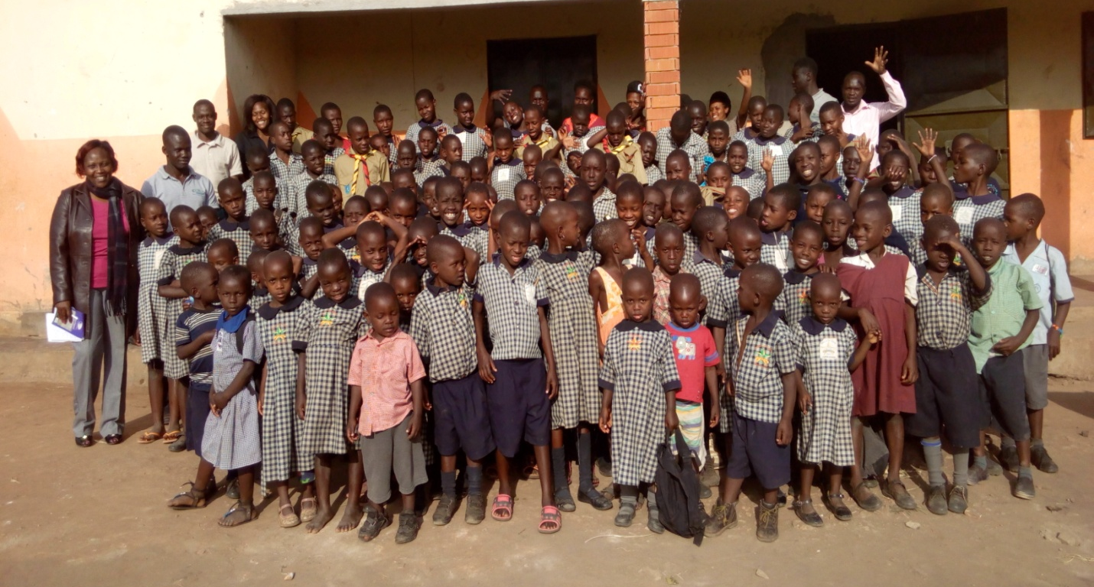
We are glad to have conducted the International Study Week from 18th to 23rd June 2018; and this year’s theme was “Inspiring effective practice through supporting children with a parent in prison.” This year, we hosted Alice Macharia, a PHD student at Kingston London, UK; she is a law student. Her research was about exploring the state’s duty to punish mothers without the expense of a child; her area was children imprisoned with their mothers.
On 18th June, 2018, Alice was picked from the airport by Francis Ssuubi, Wells of Hope founder and Sempa Sabbiti, the driver.
Alice later met the organization Accountant and Assistant Communications Officer. The Wells of Hope team shared about the origin of the study week and what Wells of Hope does. She was taken through the study week activities.

Day One
Accompanied by Ellen Eva Ssuubi, Wells of Hope Executive Director and Lucy, Wells of Hope Assistant Communications Officer, Alice interacted with Foundation for Human Rights Initiative (FHRI) and Girl Child Network (GCN); organizations Wells of Hope Ministries is partnering with. Later, she interacted with Wells of Hope staff and some of their beneficiaries at Wells of Hope offices.
Meeting at FHRI
At FHRI, the team interacted with Connie Samantha, FHRI Projects Manager. Ellen and Lucy shared about the origin of the study week and Wells of Hope interventions respectively. Ellen appreciated FHRI for raising awareness about the plight of children with incarcerated parents. Connie shared about the origin of FHRI and different programs conducted by the initiative, some of which included:
- My Rights My Power; it is a program to empower women and sought partnership with Wells of Hope (WOH) if the organization could come on board and empower mothers of children with incarcerated parents
- Abolition of the Death penalty; Connie shared that together with WOH, FHRI conducts commemorates the abolition of the death penalty every 10th October 2018. She said that during the event, among the participants are members representing the court martial. She added that during the celebration, children express the way they feel.
- Human Rights training sessions in universities; the initiative empowers the youth.
- Prisons outreach; the initiative has representatives in every welfare department at all prisons. The FHRI representatives are in touch with inmates. The initiative trained prison staff on how to handle inmates. She added that the main challenge was that inmates tell lies.
  - Ellen added that they also lie about their bio data as Wells of Hope interacts with them.
- Legal Aid (probonal); the initiative reaches out to the vulnerable and poor for example in areas concerning family land.
- Ask The Expert; it is an Open Day where the public get to inquire about various sectors and the government is always represented.
- Legal Aid Camp; this comprises one on one sessions
NB:
Connie reported that she was yet to hold a victims seminar next year at FHRI offices and she said that most were former death row inmates, prisons staff and children. She expressed a need for a children’s court.

Questions and Answer (Q & A) Session
Alice inquired about what the Initiative was going to do to help the hawkers and mothers in the markets;
Connie said that the initiative had already reached out to 6 markets; she said that demonstration farms had been put up to equip mothers with skills. She added that premaculture was the best way to approach climate change. Other skills taught included: soap and skin oil making; mothers teach their families as well. Connie said that the youth as well as the grown-ups are trained in ICT (Information and Communication Technology) so that they can market their products.

Alice inquired whether farmers are also empowered;
Connie said that it was challenging because most women do not own land especially in the remote areas. She added that their husbands or male relatives always saw it as a threat to let their wives or female relatives to own land. She added that FHRI sensitizes women to know their rights.
NB:
- On another note, Connie said that the French Embassy likes work which entails women. She said that the embassy has a program called Civic Education & Culture. She advised WOH to apply; she said advised the organization to apply for one year and then renew. Connie suggested that children could be used to act out something; she said that she’s willing to help and has a friend who writes plays.
- Connie also invited the organization to submit a proposal to France about Death Penalty and Women prisoners.

Alice inquired whether the initiative does presentencing reports;
Connie said that the initiative has guidelines for death penalty; and that they were looking into mitigating factors. She added that the FHRI Executive Director was working with the judicial sector to come up with the general guidelines.

Alice inquired about how the initiative came up with the guidelines for the death penalty;
Connie said that there was a lot of congestion in prison and saw a need for the guidelines.

Meeting at GCN (Girl Child Network)

At GCN, Christine Adero, Vivian Agaba and Emily (an intern of the organization) shared about the work they do. The Vivian shared GCN is a community based organization at grassroots; addressing rights and empowerment of the girl child. Vivian said that they reach out to girls in schools and communities where they form clubs. Vivian said that they empower clubs; the children are involved in campaigns. She added that their area of coverage was Kampala, Masaka, Wakiso and Nakaseke.
Some of the programs shared about included:
- Opportunity program; the organization equips girls out of school with knowledge.
- Girls at Risk; the program is geared at fighting for rights of the girl child.
- Women Role Model programme; the programme is a bridge to help girls meet their idols.
- The organization offers legal aid and preventative approaches.
- Sensitization; GCN empowers sensitizes children about their rights and encourages them to use their voice.

Questions and Answer (Q & A) Session

Alice inquired about whether the organization works with the government;
Vivian said that the GCN works with the Ministry of Gender to fulfill their objectives.

Ellen inquired about how many girls GCN had reached out to;
Vivian responded that more than 3,000 girls had been reached out to.

Alice inquired about how GCN empowers its beneficiaries;
Vivian said that it was a step by step process; she said that they use journals. Children address what they would like GCN to facilitate about. They also use the 5D cycle; Emily shared that the cycle symbolized Define, Discover, Dream, Design and Destiny. She said that under Define, children bring thoughts together; then what they discover is what they write in their journals and it is from then that the organization figures out how to address the children’s issues.
Christine added that the organization utilizes art therapy; and from the children’s drawings, they are able to know what the children’s thoughts are.

Alice inquired about how the organization came up with the cycle. She added that unfortunately most girls live to other people’s expectations;
Through encouraging the children that situations shouldn’t dictate their future.

Alice inquired about the organization’s level of satisfaction and how society addresses their interventions;
Vivian said that they feel a certain level of satisfaction though they need to do better. She added that how society looks at the origination is relative; some people who understood that they were doing well for their children warmly welcomed them. She said that however, there was resistance in some areas.

Alice inquired whether in areas with resistance; people would receive information better from a man;
Vivian said that if it was something about boys, the organization partners with a male person. Christine added that the information dissipated to children was limited; she added that it was frustrating to see or hear incidences happening to children and not being able to do anything.
NB: Alice said that there was need for a platform especially in schools.

Christine inquired from Alice how she plans to carry out her search; how to address the balance in sentencing an expectant mother and the unborn child;
Alice said that it was a challenge; she said that governments should see ahead of the unborn child;. She added that the unborn baby should be catered by the state; and he/she should be entitled to family life and human rights.

NB: Alice expressed a need for documented research. She said that proposals should be written based on what the organization has; the state should know that children are entitled to their rights and children should be taught to be assertive.

Visit at Wells of Hope Offices

In the afternoon, Alice interacted with Wells of Hope staff at the secretariat and with two mothers of children with incarcerated parents.
At the office, she was warmly welcomed by the staff; she was got to know more about what Wells of Hope does.

The highlight of the day was the testimonies shared by Margret and Susan, the mothers; who are some of the beneficiaries of the organization:
Margret said that his husband was imprisoned when Swaum, their daughter was only 7 months old. Her husband was the sole provider of the family; after imprisonment, she stayed with her in-laws for 6 months before she decided to fend for herself and her daughter. She said that at her mother-in-law’s home, she was nicknamed as “the cursed one”; her husband’s family blamed her for their son’s (her husband’s) imprisonment. As a result, she decided to leave the home. She said that her daughter before joining Wells of Hope, she could not afford money to take care of her daughter, rent for the one-roomed house they were staying in and also her daughter’s school fees. She’s glad that Swaum visits her father in prison thrice a year, and is in school (Wells of Hope High School).

Susan shared that when her husband was imprisoned, she lost hope in life. She said that her husband was convicted and sentenced to death row; on hearing this, the husband’s relatives proclaimed him dead. Susan’s mother-in-law’s health deeply deteriorated. Susan and her three sons lived in a very deplorable state; she could hardly afford a meal and neither their school fees.
She said that when Wells of Hope visited her and told her that they would take her children to school; and that they would visit their father in prison, she was greatly amazed! She’s very grateful to Wells of Hope for restoring hope in her life and for taking care of her children. She said that when she took her mother-in-law to visit her son (Susan’s husband), her health greatly improved.

Day Two

On Tuesday 19th June 2018, Francis Ssuubi, Wells of Hope founder and Patricia Musiimenta, Wells of Hope Projects Assistant accompanied Alice Macharia prison. She interacted with parents in Condemn section at Upper prison Luzira and mothers at Women prison Luzira.
In both prisons, the meetings started with an opening prayer, introductions then opening remarks from Francis. He thanked the parents for showing up on such a short notice. He explained to the parents that every year Wells of Hope conducts a study week which is mainly to study about the children with a parent in prison and their welfare. He went ahead to explain that the government doesn’t take enough responsibility to look after children, after their parents have been arrested and later on sentenced to many years in prison. He said that every year, Wells of Hope gets people from different countries all over the world to come and learn about these children and see how they can help them.
He introduced Alice Macharia to the parents. He shared with them about what she was studying and what her research entailed. He explained that the parents would get to talk about their experiences and testimonies and explain how Wells of Hope has helped them.

The inmates were asked to talk about the following key topics:
- How they felt when Wells of Hope reached out to them
- The challenges they faced when they were arrested
- The state they left their children in and whether they were aware of their arrest
Meeting with the fathers
One of the inmates narrated his story and said that the day he got arrested, he had no hope that his children would survive. He was the sole bread winner and his family completely depended on him. He was later sentenced to life imprisonment and he knew his children’s lives would be ruined forever. However in 2012, while in prison he received forms from Wells of Hope and he was requested to fill in and the organization promised that they would look after his children. He explained that at first it was hard for him to believe that people he was not related to or even knew would have interest in his children but by God’s Grace they offered to take care of his children. He expressed his gratitude towards Wells of Hope and said if it weren’t for them, he would have never seen his children at all.
Edson a father of seven was arrested in 2012. He has been in prison for the last 13 years. He described how hard it was to leave his children behind with nothing at all. He went ahead to explain how his wife had no job and he left nothing behind to support his family. He shared that when Wells of Hope stepped in, it offered help to two of his children and that the rest of the children were still at home not studying because of lack of school fees. He appreciated Wells of Hope for reuniting him to his children; he had taken 7 years without seeing them. He said that he had last seen his son when was 4years while the daughter was only two weeks old.
Meeting with the mothers
A mother of two described her arrest as one of the hardest moments in her life. She said that the day she got arrested, her children were left with no one at all. Her husband had been arrested earlier on. She thanked Wells of Hope for all they have done to reach out to her and her children.
Alice concluded by thanking them and encouraging them not to give up on life and above all never to forget that despite them being in prison, they are still parents.

Day Three
Alice visited Wells of Hope High School and Wells of Hope Junior School where she interacted with the children with parents in prison.
Visit of Wells of Hope High School

At Wells of Hope High School, Alice was given a grand welcome from the children and Charles Ssenoga, the school head teacher. The head teacher shared with her about how and why the school was started; he also shared with Alice about the programmes conducted with the children. He later guided her as she took a tour of the school.

Alice was then guided to the main hall where the rest of the school had merged. The head teacher gave the opening remarks and later on, the children entertained the visitor in mimes and a poem.
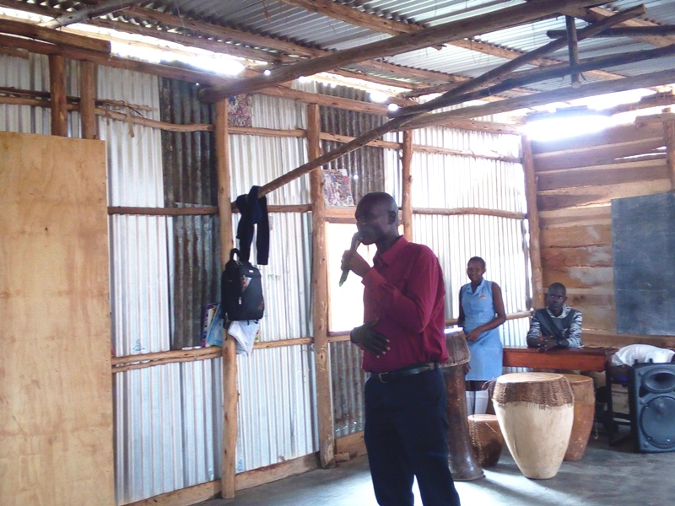
The head teacher giving opening remarks
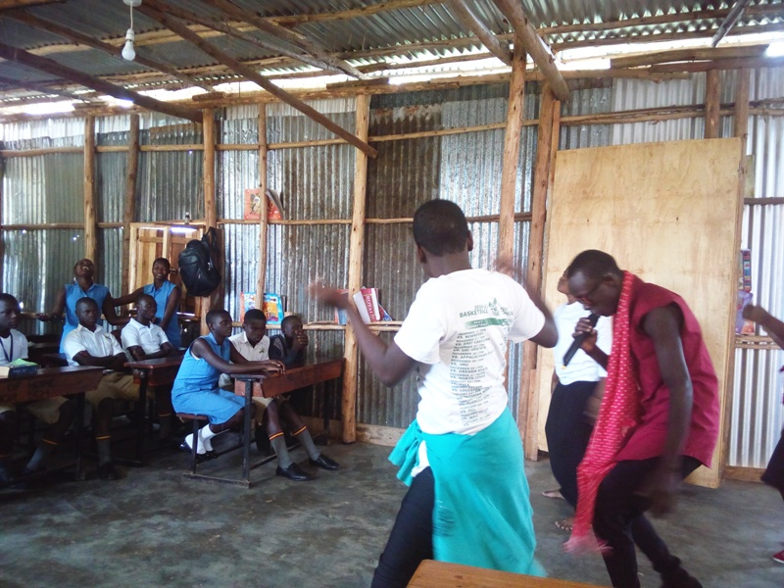
Entertainment; students presenting a mime
Children shared their testimonies;
James Bob Twesigye shared that before joining Wells of Hope, he used to stay with his aunt and he did not know who he was. When he inquired about him, he was told that he died in prison. He was not in school and they could hardly afford a meal in a day. When Wells of Hope visited him and told him that he would be taken to visit his father in prison, he was shocked; doubts filled his mind because what the organization had told him was contrary to what his relatives had told him. “I could not believe that my father was alive until Wells of Hope took me to visit him in prison,” Joseph said. He’s now happy that he’s in school and that he visits his father thrice a year. James expressed deep gratitude to Wells of Hope for the continued support towards his future and for enabling him get to know his dad.

Later, Alice shared with the children about her work and research. She advised the students not to wait for someone to tell them what they should be in future; she advised them to start living in their dreams then and to enjoy the journey.
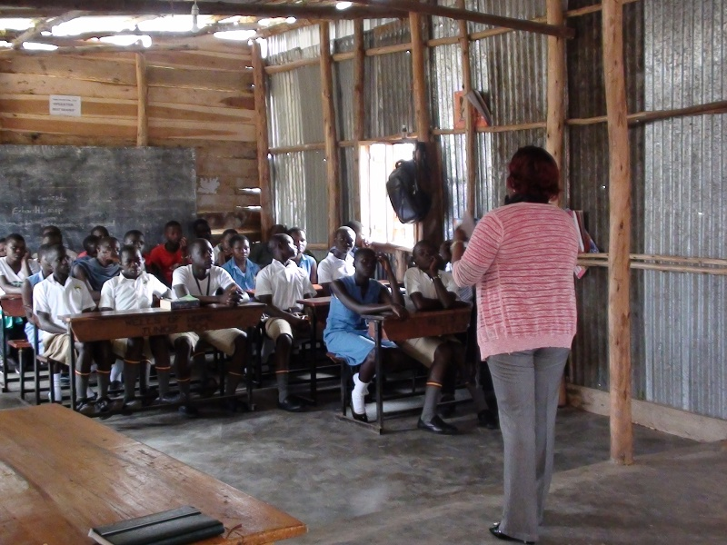
She cautioned them not to wait for years ahead; and to be true to themselves. She encouraged them to always seek God’s guidance. She encouraged them to focus on their studies and change the world; “there’s hope with discipline, hope and hard work,” she said
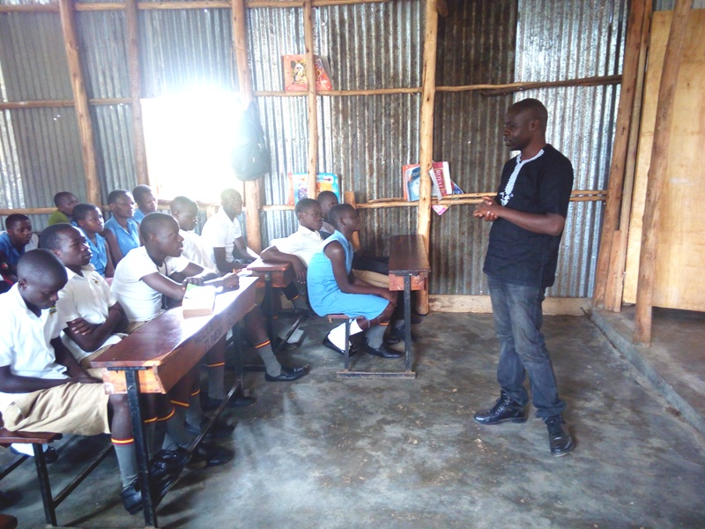
Francis Ssuubi moderating the Q & A session during the visit

She had a one-on-one session with the children; the children freely opened up to her regarding their social and academic life. The children expressed their gratitude towards Alice for the advice she shared with them.

Visit of Wells of Hope Junior School

At the school, Alice was warmly welcomed by the children and Charles Ocoper, the school head teacher. Accompanied by the Charles and the scouts team, she was guided as she took a tour around the school; and later shared a lovely meal with the children. The children in kindergarten and the Crafts club later presented to her what they had prepared for her.
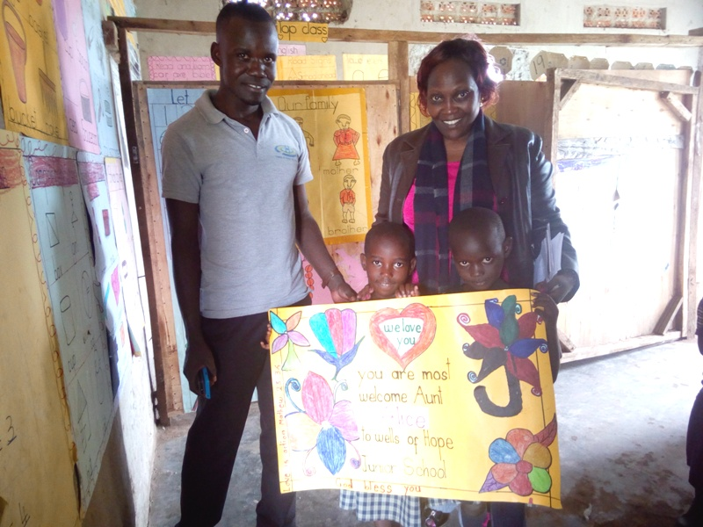
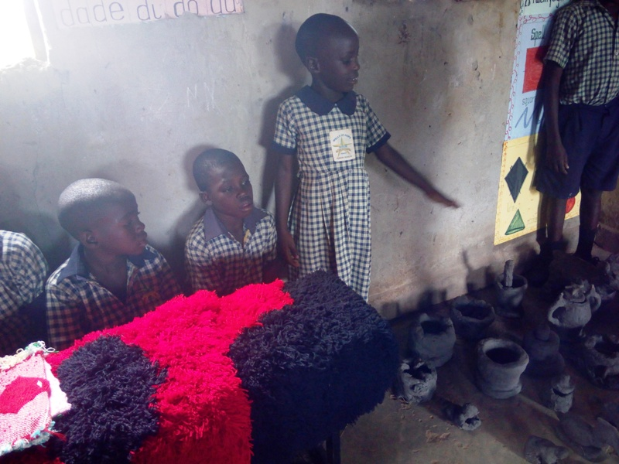
She was happily entertained by the children through music and dance; the children wore wide smiles during the presentations; and Alice couldn’t help joining them.
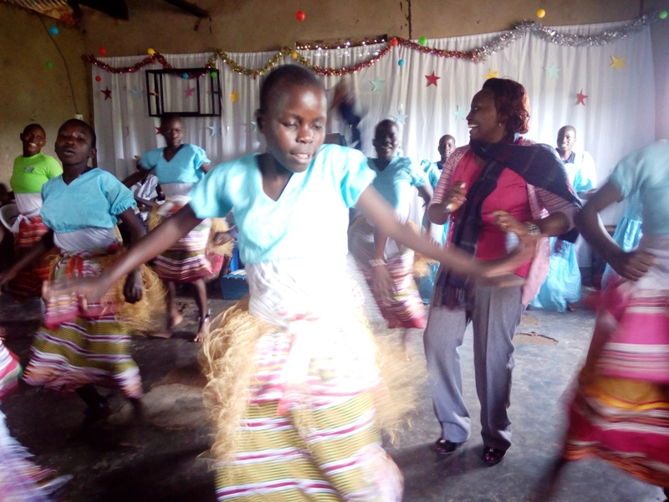
During her interaction with the children, Alice encouraged the children to hold onto their dreams; to start small and move ahead.

Some of the highlights for the day were:
- The welcome chart done by the children in kindergarten; “Aww… this was so thoughtful of these little ones, I am truly amazed,” Alice said, with a very wide smile on her face.
- The confidence the pupils displayed as they explained to Alice how they make crafts and do pottery.
- Testimonies shared by the children:
Samalie, Ruth and Joel shared that before joining Wells of Hope, they did not know who their parents were until Wells of Hope took them to visit them in prison. “Before joining Wells of Hope Junior School, I had stopped studying. I was in a government school; my grandmother needed 1,000/= for school fees, but she could not afford school fees as well as food to eat. But when Wells of Hope came to our home and told us that they would take me to school and that I would visit my dad in prison, I was very happy,” said Samalie

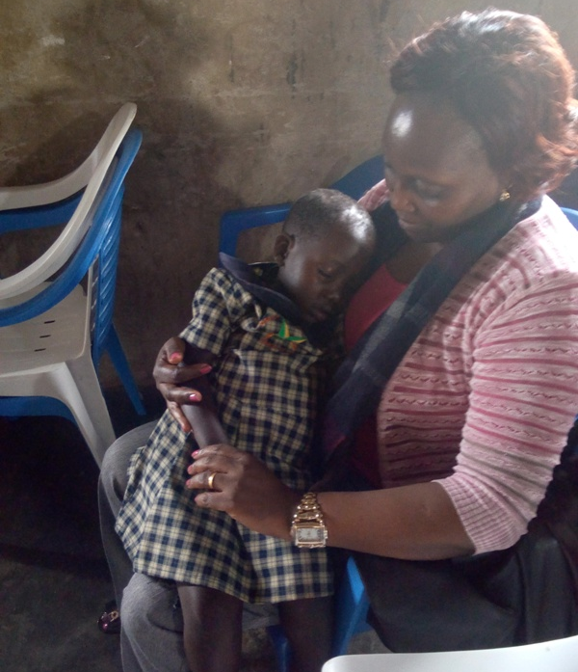

Day Four
Meeting at National Children’s Council (NCA)
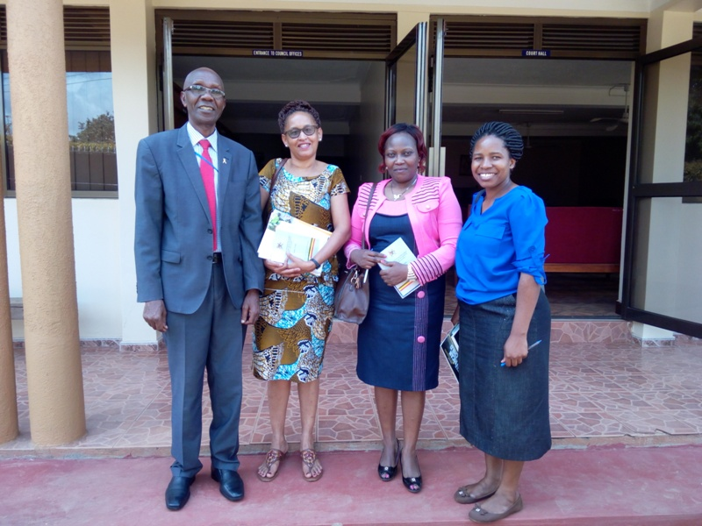
Alice, Ellen and Lucy were warmly welcomed by Mr. Kiiza Martin, NCA Executive Director.

Mr Kiiza said that NCA was established by law to address children’s needs and concerns for example children with disabilities and children with parents in prison. He said that the authority was established for; Proper coordination, Monitoring and Evaluation of all programs in the country, sector ministries, public and government sectors, district local governments. They sensitize the district local government leaders on how to address issues about children in their mainstream; in their plans and budgets. In other words, they task the District Local Governments (DLGs).
He shared NCA interventions, which included:
- The Authority works hand-in-hand with partners; there are advocacy forums where participants; convene advocacy meetings. The participants meet and forum for children where partners share their challenges and address a way forward. He said that the study week helps to shows a participant what’s on ground.

- Early Childhood Development (ECD); sensitize for proper growth of children. He said that the Authority utilizes documents created by the government;
- The ECD Policy
- The Parenting Guidelines
- The Children’s Act
- Local Government Act
- Child Participation Strategy
- Integrated ECD Policy; from conception to 8 years
- Advise the government on child rights programs and policy
- Create awareness about abuse on children and prevention
- Monitor implementation of laws
- Monitor implementation of investigations under Section 9B Sub-section F.
- Information sharing through quarterly reports or updates
- Deal with referrals
- Do joint visits; where they monitor and evaluate
- Hold partnership meetings
- Capacity building; the Authority is part of the National Organization Committee.

Mr Kiiza reported that some of the main challenges faced by the Authority are:
- The negative attitude towards children; some people think that children don’t matter. He said that they encourage children to be in their families for proper growth and for a child to diversify.
- Funding; Mr Kiiza said that the authority encourages partners or stakeholders to use and strengthen mechanisms. In other words, to use what they have.
NB
- Alice expressed a need to appreciate what Wells of Hope is doing for the children because when the children are left alone with no one to take care of them, they become criminals.
Mr Kiiza said that there is a need to spread more and focus on looking in the best interest of the child. He said that the Authority works with the civil society, the government and its implementation; he said that the Local Government had submitted reports already. He encouraged Alice to come up with an implementation policy.
Mr Kiiza added that the Authority was looking at harmonization of child laws at regional level. He said that there is need to strengthen networking.
- Alice expressed a need for more awareness; address the children of the offenders and the victims.

Question and Answer (Q & A) session
Alice inquired about how the Authority ensures that imprisoned children are comfortable from day1 to 18 months.
Mr Kiiza said that the authority provides guidance to different actors.
Day Five
Alice interacted with Stella Agwang, Probation and Welfare Officer at Ministry of Gender and later visited two families of inmates.
At the Ministry of Gender, Ellen shared about Wells of Hope and about the study week.
Question and Answer (Q & A) session
Alice inquired about how the probation and welfare office helps the court in sentencing expectant mothers.
Stella said that the office prepares sentencing reports for adults and social reports for children. She said that a probation officer prepares a social inquiry report before going to court; he or she talks to the community of the child and the complainant. The officer prepares the report based on ground and the case. For pregnant mothers, a report is prepared as well, but the Children’s Act allows children under one and a half years to stay with their mothers for 18 months; this is for social and scientific reasons. She said that most offences committed by mothers are social and they suffer revenge from the community. She said that rather to leave the child in the community, it’s better to have the child around for consolation.

Alice inquired whether the mothers are held accountable traditionally
Stella said that there’s need for a traditional aspect for some traditions; she added that some families do rituals to exonerate them.

Alice inquired what happens to a pregnant woman and has been charged with committing murder
Stella said that court waits for the woman to give birth before she’s sentenced. She said that there’s no more hunging in prisons.

Alice inquired about the impacts of the reports
Stella said that each one has its own merits and demerits; the social and legal reports have their own impacts. She said that a person cannot just go back to the community; she said that if one has committed a crime, he or she should serve their sentence and then return to the community. She said that prison is a correctional facility.

Alice inquired whether government is involved;
Stella affirmed and said that the report helps the judicial officer to know what the community thinks; she said that the report offers guidance during sentencing.

Alice inquired whether the victim is considered;
Stella affirmed and said that the probation office cannot look at the offender unless the victim is considered as well; in other words both sides are considered.

Alice inquired whether there were facilities for girls below 18 years;
Stella affirmed and said that there’s a remand home. She said that there were 7 remand homes and 1 rehabilitation center.

Family Visits
Two families of inmates were visited in Mukono and Kayunga districts, central Uganda. Alice was accompanied by Francis Ssuubi, Wells of Hope founder, Patricia Musiimenta-Wells of Hope Projects Assistant, Sandra-Wells of Hope Volunteer and Lucy-Assistant Communications Officer.

The first family
Namunane’s Family:
On arrival, the Wells of Hope team was welcomed by Mr. Masanvu the brother to the inmate; he picked the team from the trading centre and later took them home. At home, the team was welcomed by Nabukonde Felista, the grandmother of the inmate and Nambooze Felista, the mother of the inmate. The founder introduced the Well of Hope team to the family and also told them the reason why they had visited them.
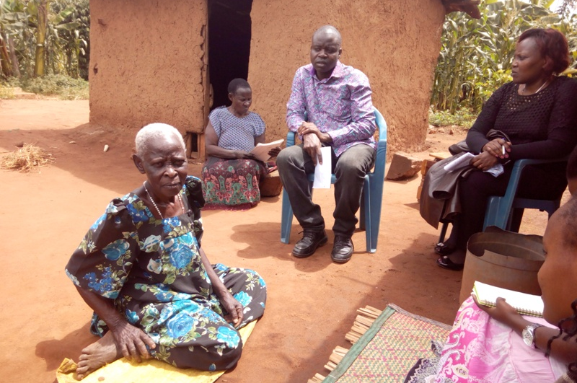
With the help of the family, the team found out that the inmate has four children, that is Nabukwazi Edina who is 21 years old, Mabonga Patrick 19, Nabukwasi of 14 years and Namunane Jim who is the last born with 7 years. Each of these children has his or her mother; they all abandoned their children. Namunane Jim who is the last born stays with a grandmother who is the sister to the mother of the inmate and she is the one who currently pays school fees for him through selling coffee from the garden. Jim goes to Busita primary school at Budadili and he is in primary two currently. The mother of Gim went back to masaka and they do not know her whereabouts. The only child who stays at the home is Nabukwasi who’s currently in primary seven. The team was shown where she sleeps; and noticed that it was not safe at all; she’s susceptible to rape.
The team had an opportunity of interacting with Nabukwasi at her school, which was not far from home. The team was also told about Nalongo, the fifth wife of the inmate; who is now taking care of the inmate at the moment but she has no child with him and she is the one who was initially taking care of the children when their father had just been taken to prison.
In conclusion, the Founder talked about Wells of Hope, its location and about what the organization could do, why the organization takes the children, and when the organization started.

The second family
Nakandi’s Family:
The mother of the inmate was not welcoming; she first lied about her location and was not interested in interacting with the Wells of Hope team.
However, she told the team that she does petty jobs like mixing sand at construction sites and washing people’s clothes to get money to buy food and pay her grandchildren’s school fees. She takes care of 10 grandchildren and 5 of them are the inmate’s and these included: Lubanja Elisa 15 years, Biss Mugidde 10 years, Sikola Nadunga 8 years, Lawrence Ssekome 5 years, Negesa Mbattidde 4 years. She said that their mother had been imprisoned for about 3 yrs then. Unfortunately the team did not meet the children because their grandmother said that they were at school; she said that the team would meet them next time.
The founder told her that there are organizations that take care of grandmothers; he encouraged her to visit ROTOM, a charity organization in Mukono district (her home area). She said that she had never heard about it and added that once some people learn about such organizations, they can never tell others about it. She said that organizations at times take on their relatives or people they know.

Day Six
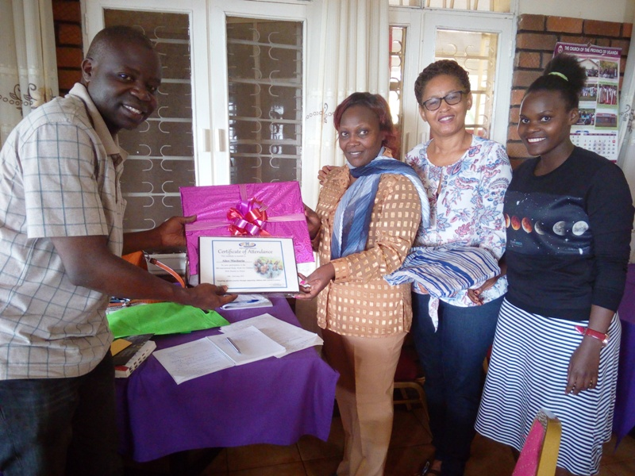
The wrap-up meeting was held at Namirembe Guest House. The meeting was attended by Alice and Wells of Hope staff who included: the Founder, Executive Director, Assistant Communications Officer and Projects volunteer. The meeting was aimed at discussing the activities carried out during the study week, to see what has been done and discuss action points.
The founder appreciated Alice for coming and interacting with the team from Wells of Hope and the children at school. He also appreciated the team at Wells of Hope for their cooperation during the study week. He said he personally benefited from Alice’s coming to Wells of hope that he learned a lot from her.
Alice appreciated the Founder and the Executive Director for allowing her come to Wells of Hope. She said that she benefited a lot from the study week and that she was impressed when she visited the office. She appreciated the fact that the office structure is Godly and said that Wells of Hope will be the voice of the voiceless. She appreciated Ruth, one of the children at Wells of Hope Junior School and said that we should always look out for the less privileged and lift them up in to the lime light.
She went on and talked about Mr Kizza, NCA Executive Director; she said that he is going a long way to support Wells of Hope. She said that Mr Kizza wants reports from Wells of Hope and that the organization needs to get him a day together with the judges to visit the schools. The founder said that we should also organize a day for the judges and we talk to them so that we ask them on what the court can do for the families of the inmates.
Alice said all her questions were answered very well and to her expectation. She said that as she goes back to Kenya and happens to identify any needy case there, she would inform Wells of Hope and they see what they can do. She said that Wells of Hope can always call her whenever they need her; and that her daughter can always come to stand in for her and give her the information. She also said that in Kenya, there are many children inside and outside prison that later end up in terrorism, and asked Wells of Hope team to try and link her daughter to the team.
Alice said that all the meetings she attended went very well most especially with Connie, and she said that Wells of Hope can even partner with her. She reported that during the meeting, they talked about land, sensitizing women for their rights and how to utilize their land and suggested Wells of Hope could give them seeds. She also reported that Connie shared about FHRI and how Wells of Hope can work with them more.
Alice reported about the meeting at Girl Child Network and found out that the organization has sensitized children on forms of sexual harassment but their main challenge is that they are not given chance to talk to the children. She also said that when she visited the prisons, she found out the heads of prisons also do not know what to do with the babies in prison.
Wells of Hope gave Alice gifts, a certificate of appreciation; she was very happy about the gifts and the certificate. She donated funds towards mosquito nets for boys at Wells of Hope Junior School. The founder apologized for the poor accommodation at the Guest House.
Achievements:
- The study week was held
- Alice’s expectations were met

Highlights:
- Good time-keeping especially at the schools.
- The participant was very passionate about children.

Challenges:
- Poor accommodation; the rooms at the guest house had caterpillars and the wifi was terrible.
- The visitor expected a conference. She was very happy with the way the partners responded to her inquiries. She appreciated Wells of Hope for the work the organization is doing to support children with parents in prison.

Recommendations:
- Ask participants about their expectations
- More advertising about study week is needed.
- Partners should be informed very early.
- Participant’s profile should be more detailed.
- Make thorough survey of the hotels.
- Appreciate all partners who participated.
- Revise the study week program and Inform the participant ahead of time about how many people will be attending the study week

Action Points:
- Strengthen partnerships/networks
- Send quarterly reports to NCA
- Document all research; especially for proposal writing
- Submit proposals to the French Embassy

